**COMHAIRLE CHONTAE AN CHABHAIN**

**CAVAN COUNTY COUNCIL**

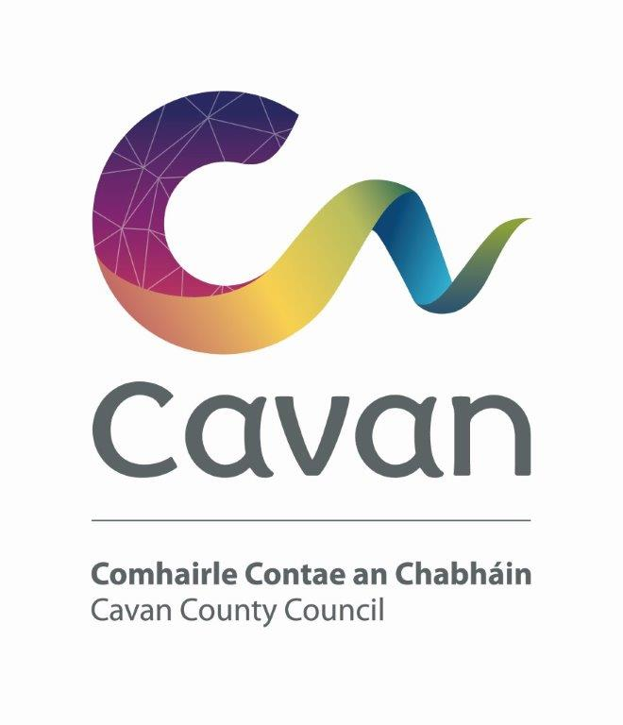

**Strategic Policy Committees Scheme**

**2024-2029**

**DATE September 2024**

**Background**

The statutory basis for Strategic Policy Committees (SPCs) is set out in the Local Government Act, 2001, as amended by the Local Government Reform Act 2014. Each Local Authority is required to establish SPCs in accordance with guidelines published by the Department of Environment, Heritage and Local Government: “Strategic Policy Committees – Guidelines for Establishment and Operation issued in June 2014”. The rationale for setting up SPCs is to provide forums where Local Authority Members and relevant sectoral interests with specific expertise can work together and advise and assist the Council in the formulation and development of policy. Ultimately the Council remains the decision making authority.

SPCs meet regularly to deal with policy issues of the Council. Recommendations are, in the main, reached by consensus and presented to the full Council for approval. Each SPC is facilitated by a Director of Service.

The SPC system is intended to give Elected Members and relevant sectoral interests an opportunity for full involvement in the policy making process from the early stages when policy options are being considered. The SPC system allows much of the preliminary and background work to be completed at SPC level before final consideration and ratification by the Council.

Following the local elections 202024, each Local Authority is required to review its SPC scheme and approve a new scheme to operate for the lifetime of the Council.

**Role of Corporate Policy Group and Strategic Policy Committees**

The Corporate Policy Group (CPG) links the work of the different SPCs and provides a forum where policy positions affecting the whole Council can be agreed for submission to the full Council. The CPG comprises the Cathaoirleach of the Council and the Chairs of the SPCs. It is supported by the Chief Executive and Directors of Services.

The role of SPCs is to assist and advise the Council in relation to functions of a strategic statutory nature. They also have a function in other non-statutory policy areas such as policy related to the development of work programmes and the establishment of priorities for particular services. SPCs will be involved from the preliminary phase of preparation of a policy and assist in the setting of overall parameters, identification of issues to be addressed and approaches to be taken etc.

**Meetings**

Meetings will be conducted in accordance with Cavan County Council’s Standing Orders and subject to law or amendments made by Cavan County Council. Within this framework, each SPC may regulate its own business and proceedings (including the fixing of days and times of its meetings). SPCs will be required to meet four times annually and more frequently if necessary. Meetings will be held at a suitable time for the SPC members.

**SPC Framework**

Having regard to Cavan County Council’s organisational structures, the areas of responsibility assigned to each SPC are as follows:-

**1**. Economic Development, Enterprise and Planning

**2**. Climate and Biodiversity Action & Environment

**3.** Transportation, Infrastructure and Emergency Services

**4.** Housing, Social Inclusion & Corporate Services

**5**. Cultural Development, Irish Language and Sport

**Collective Objectives**

Cavan County Council will promote and integrate the use of the Irish language in the work of all SPCs.

Cavan County Council will promote and integrate wellbeing in all SPCs to craft policies that enhance overall quality of life with greater focus on the wider broader determinants of health and wellbeing considering social, environmental and economic factors in a more balanced way, leading to more sustainable outcomes.

Cavan County Council will promote and integrate the County Cavan Climate Action Plan in the work of all SPCs.

**Membership of SPCs**

Elected Members

Each Member of the Council will have an opportunity to serve on one SPC. Cavan County Council’s representation shall be six Members on each of the committees. This is in order to achieve a balance between Elected Members and sectoral interests on each SPC. Therefore, twelve Elected Members shall serve on two SPCs.

Sectoral Representatives

Sectoral representation on each committee is set out in Appendix 1. The membership of each committee shall be determined by the Council after closing date for receipt of notification to participate in the nominating process.

At a minimum six and where appropriate seven sectors should be represented in each SPC configuration. External representatives may be nominated by the following sectors:

* Agriculture/Farming
* Environment/Conservation
* Development/Construction
* Business/Commercial
* Trade Union
* Community/voluntary
* Social Inclusion

Nominations to the SPCs from the agricultural/farming, business/commercial, development/construction and trade union sectors will be organised by the designated contact person from the relevant National Pillars.

The environmental/conservation sector will be facilitated by the environmental pillar and the associated Environmental College under the Public participation Network (PPN)

The community/voluntary and social inclusion sectors will be determined on the basis of the local nomination process through the PPN.

Nominees will be expected to have a specific interest in the areas under the remit of the particular SPC.

The Sectors shall achieve a 40% gender balance in the making of appointments as well as the need to foster social inclusiveness and equality when selecting their representatives.

The assignment of sectoral interests for each S.P.C. is as follows:

|  |  |
| --- | --- |
| **Sector** | **Number of SPC places**  **(5 SPCs)** |
| Agriculture/Farming/Rural Water | **3** |
| Trade Union | **1** |
| Development/Construction | **3** |
| Business/Commercial | **4** |
| Environmental/Conservation | **2** |
| Social Inclusion | **2** |
| Community/Voluntary | **5** |
| **Total** | **20** |

The areas of responsibility relevant to each of the five Strategic Policy Committees are set out in Appendix 2.

**General**

* The Chairs of the SPC’s have been appointed by the full Council from among the Councillor appointees to the SPCs. SPC Chairs will hold office for a minimum period of three years.
* It is desirable that sectoral nominees retain membership of the SPC for the life of the Council. Where a casual vacancy occurs, it should be filled by the relevant sector.
* The relevant Director of Services will attend meetings and provide support to the SPC. The Director will, subject to the Chief Executive’s overall responsibility for staffing matters, work closely with the Committee and be entitled to speak and participate at meetings.
* S.P.C. membership for Councillors will be for the lifetime of the Council.

**Lobbying Act 2015 – Transparency Code**

The Regulation of Lobbying Act 2015 (the Act) is designed to provide information to the public regarding who is lobbying whom about what. Individuals and organisations who participate in Strategic Policy Committees established by local authorities may have obligations under the Act. A critical element of public policy formulation by the Strategic Policy Committees is the availability to the local authorities of expertise, skills and knowledge from persons outside of the public service. Where membership of the Committee comprises of at least one person who, for the purposes of the Act is a Designated Public Official, it may be the case that communications within the group could be considered lobbying communications. The person making these communications may be required to register as a lobbyist and to submit a return of this communication to the Lobbying Register. However, the Act provides for an exception from the requirement to register in such cases once specified transparency criteria have been put in place. A transparency code was published by the Minister for Finance and Public Expenditure and Reform to address this situation. Communications between members of Strategic Policy Committee about the work of the Committee would be exempt where the group in question complies with the Transparency Code. All agenda items, minutes of meetings and related matters will be available on the Cavan County Council website for viewing.

**Disclosure of Interests**

The ethical requirement of Section 177 of the Local Government Act 2001 shall apply to all members of the SPCs (including non–elected members) i.e. Disclosure by a member of pecuniary or any other beneficial interests. The general conduct and behaviour of SPC members in carrying out their role is an important yardstick by which the honesty, integrity, impartiality and performance of local government is judged, and public trust maintained.

**Conclusion**

This scheme will be considered by the Elected Members of Cavan County Council at its meeting on _________________________

**Appendix 1 Strategic Policy Committees 2024-2029 Membership**

*6 Elected Members per SPC*

*Total Sectoral Interests = 20*

|  |  |  |  |  |  |
| --- | --- | --- | --- | --- | --- |
|  | **Housing, Social Inclusion & Corporate Services** | **Climate and Biodiversity Action & Environment** | **Transportation, Infrastructure**  **& Emergency Services** | **Economic,**  **Development,**  **Enterprise & Planning** | **Cultural Development, Irish Language & Sport** |
| **Chairperson** | **1** | **1** | **1** | **1** | **1** |
| **Elected Members** | **6** | **6** | **6** | **6** | **6** |
| **Agriculture and Farming** | **-** | **1** | **1** | **1** |  |
| **Trade Unions** | **1** | **-** | **-** | **-** |  |
| **Development & Construction** | **1** | **-** | **1** | **1** |  |
| **Business & Commercial** | **-** | **1** | **1** | **1** | **1** |
| **Environment & Conservation** | **-** | **1** | **-** | **-** | **1** |
| **Social Inclusion** | **1** | **0** | **-** | **-** | **1** |
| **Community & Voluntary** | **1** | **1** | **1** | **1** | **1** |
|  | **10** | **10** | **10** | **10** | **10** |

**Appendix 2 Indicative Areas of Responsibility**

**Housing, Social Inclusion & Corporate Services**

* Housing Capital Programme
* Social Housing
* Voluntary Housing
* Social Inclusion
* Corporate Services
* Preparation and Implementation of (Community elements) of the Local Economic and Community Plan (LECP)

**Climate and Biodiversity Action and Environment**

* Climate Change
* Waste Management Planning
* Environmental Protection/Awareness

**Transportation and Infrastructure**

* Road Maintenance & Improvement
* Road Safety
* Public Transport
* Car Parking
* Traffic Management
* Emergency Services
* Playgrounds
* Greenways
* Water Services Strategic Planning

**Economic Development, Enterprise & Planning**

* Economic Development & Promotion
* Urban & Village Renewal
* Preparation and implementation of (economic elements) of the Local Economic and Community Plan (LECP)
* Local Enterprise Office functions
* Planning & Development Services
* Development Contribution Schemes
* Heritage & Conservation issues
* National & Regional Spatial Planning
* Tourism
* Brexit
* Food Strategy
* Community Grants Scheme

**Cultural Development, Irish Language and Sport**

* Culture
* Theatre & Arts
* Library services
* Museum
* Irish Language
* Sports Development
* Sports Partnership

**Made under Official Seal of the County Council of the County of Cavan**

**this ____ Day of _____________ 2024.**

**Present when the Official Seal of the Council was affixed:**

**___________________________**

**Cathaoirleach,**

**Cavan County Council**

**__________________________**

**Chief Executive,**

**Cavan County Council**