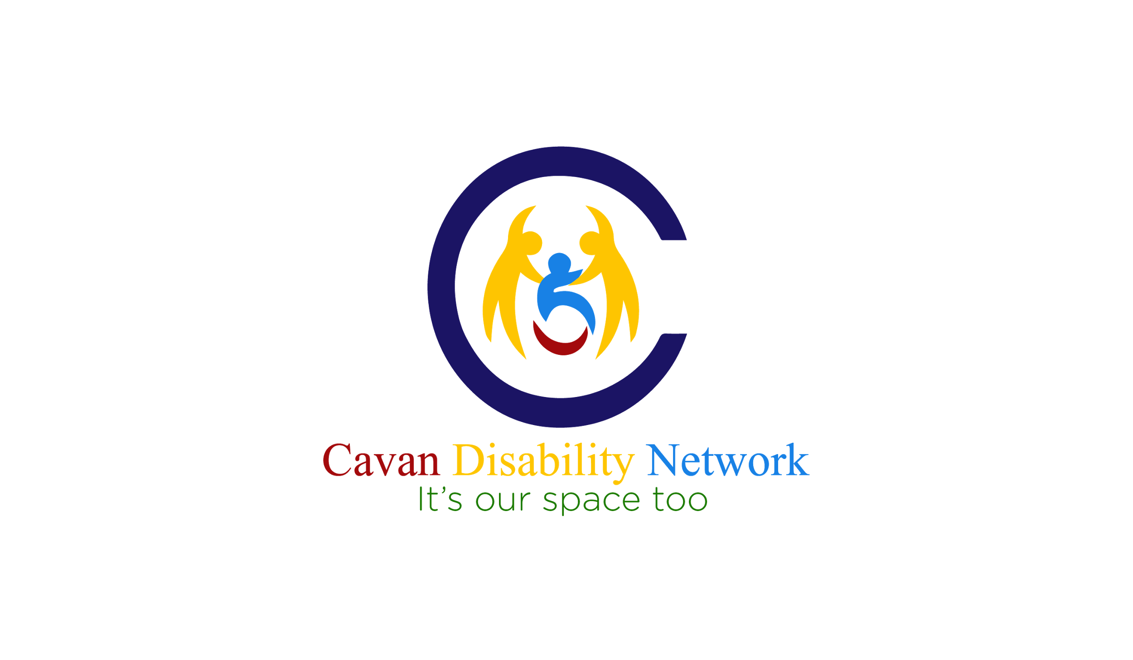

**“It’s Our Space Too”**

**Hosted by Cavan Disability Network in conjunction with**

**Breffni Integrated CLG, Cavan County Council and Cavan PPN**

**Wednesday 26th September 2018, 10.00am-4.00pm**

**Hotel Kilmore, Dublin Road, Cavan**

**BOOKING FORM**

**Place complete a separate booking form for each person attending including PA’s or family members accompanying conference attendees**

**(Limited to one person accompanying per attendee)**

**Pre-booking is essential by Friday 7th September at 5.00pm**

**Name**:_______________________________________________________________

**Mobile Phone No:**_____________________________________________________

**Alternative Phone No (in case of emergency):**________________________________

**E-mail:**______________________________________________________________

**Please state if you are a Service User or a Provider:**________________________

**Consent to Future Contact:**

**Would you like to be added to our mailing list to receive details of other events which may be hosted by Cavan Disability Network: Yes No**

**I hereby give consent to Cavan Disability Network to retain my personal data for the purpose listed above:**

**Signed: _____________________________________ Date: __________________________**

(Cavan Disability Network will not share your data with any other body/organisation. All data collected will only be used for the purpose for which it was collected and will be stored confidentially for a maximum of 12 months, after which it will be permanently deleted).

**A light lunch will be provided at the conference. Please state if you will be staying for lunch and if you have any special dietary requirements:**

Do you require lunch (Yes/No):__________________

Any special dietary requirements? ________________________________________

___________________________________________________________________

**Do you require the following assistance?**

**Sign Language Interpreting Yes No**

**Audio Assistance Yes No**

**Other (Please State): _________________________________________________**

**Due to limited spaces at the conference pre-booking is essential and on a first come, first served basis.**

Please return this completed booking form by email or post to: [cavandisabilitynetwork@gmail.com](mailto:cavandisabilitynetwork@gmail.com)

or Breffni Integrated CLG, House 1, The Réaltóg Centre, Kilnaleck, Co. Cavan

by **Friday 7th September** **at 5.00pm.**

We will confirm all bookings by return email. If you do not receive an email confirming your booking within 5 working days of returning your completed booking form please phone Lorraine on 087 983 9858.

**CAVAN DISABILITY NETWORK**

In conjunction with Breffni Integrated CLG, Cavan County Council, and

Cavan Public Participation Network are delighted to host this event.

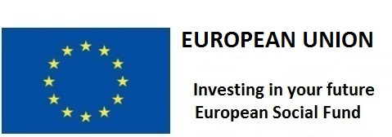

**The Social Inclusion and Community Activation Programme (SICAP) 2018-2022 is funded by the Irish Government through the Department of Rural and Community Development and co-funded by the European Social Fund under the Programme for Employability, Inclusion and Learning (PEIL) 2014-2020**

