**Design an Anti-Litter Poster & Slogan for Cavan County Council**

We are asking Primary School Children to draw a picture and design a slogan, aimed at educating their local community about the negative impact littering has on the environment.

***Three posters will be chosen and professionally printed and distributed to all schools in the County. The winning posters will also be used to promote future Anti-Litter campaigns.***

***Posters should be no bigger than A3 size and the slogan on the poster can be in Irish or English or both.***

**All Entries must be accompanied by the following details:**

**School Name:**

**School Address:**



**Class:**



**Teacher/Principal Name:**



**Contact Number:**



**Contact Email Address:**



**Closing date for entries is 5.00pm Friday 30th April 2021.**

**All entries must be sent in picture format ONLY with the application form to:** [**cboylan@cavancoco.ie**](mailto:cboylan@cavancoco.ie)**.**

**The personal information (data) collected on this form, including any attachments, (which may include the collection of sensitive personal data) is collected for the purpose of processing this application and any data collected is subject to Cavan County Council’s privacy statement which can be found at** [**http://www.cavancoco.ie/data-protection.htm**](http://www.cavancoco.ie/data-protection.htm)



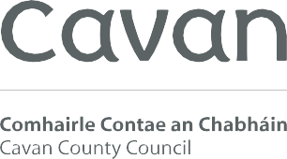

**Cavan County Council**

Waste Management Section

Old Library Building

Farnham Street

Cavan

**T :** 049 437 8409

**E: waste@cavancoco.ie**

**W:** [www.cavancoco.ie](http://www.cavancoco.ie/)

# 