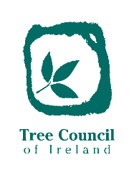
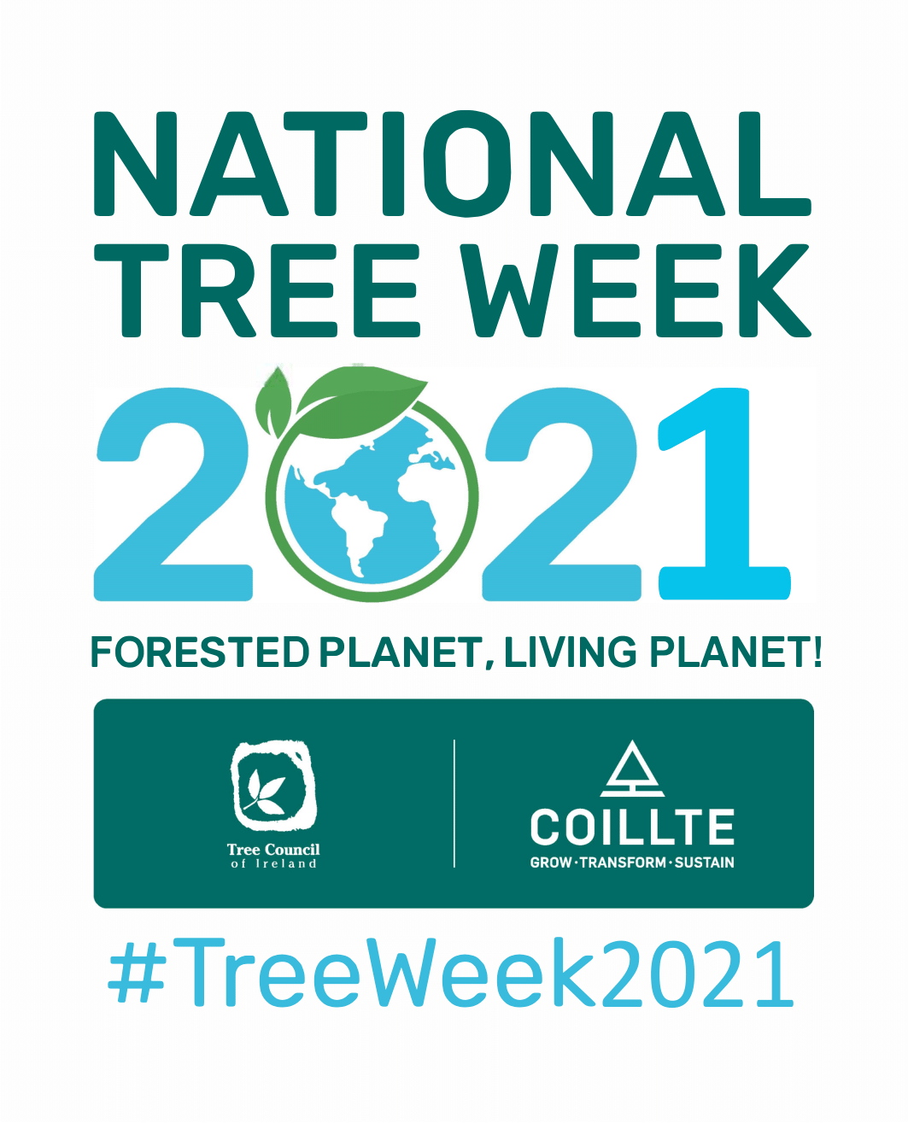
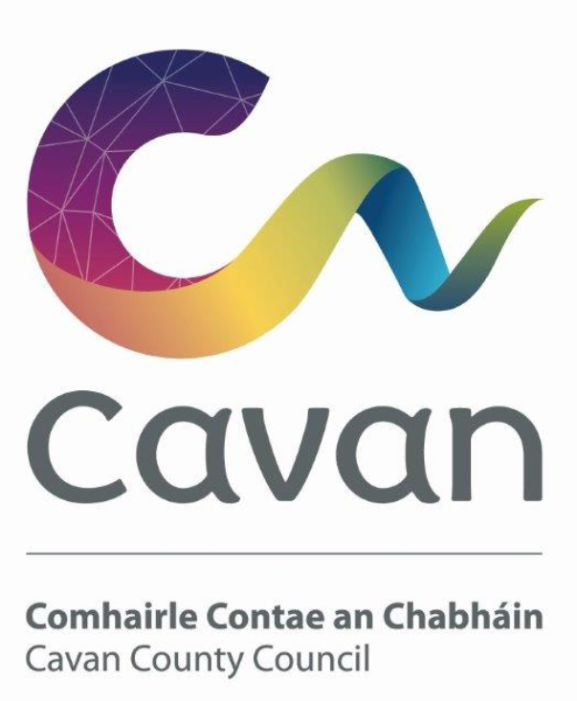

NATIONAL TREE WEEK 2021
(Sun 21st March – Sat 27th March)

SAPLING ORDER FORM
Please complete this form and return on or before 12th March 2021

Name of voluntary group: _________________________________

Your name: __________________________________

Your email: _________________________________

Your contact number: _________________________________
1.0 Did your group receive trees/saplings as part of previous National Tree Week events? (Yes/No): _________________________________

1.1 Were saplings planted successfully as part of previous National Tree Week events? (Yes/No)
_________________________________
1.2 Outline benefits of previously planted trees/saplings in your community, as part of National Tree Week:

2.0 Number of saplings required for National Tree Week 2021:
_________________________________

2.1 Provide details on where the saplings will be planted – please include a map or photo of the location where it is intended to plant the saplings:
____________________________________________________________________

3.0 Are your community implementing a Biodiversity Action Plan? (Yes/No/Don’t know):
____________________________________________________________________
4.0 Are you willing to provide photos of the planted saplings in your community for promotion through Cavan County Councils Environmental Awareness Programme (Yes/No):
_________________________________

4.0 Will you participate in the Tree Council of Ireland photography competition – details at https://www.treecouncil.ie/nationaltreeweek2021? (Yes/No):
_________________________________

For information on how Cavan County Council manages your data visit
http://www.cavancoco.ie/data-protection.htm

