Cavan County Council

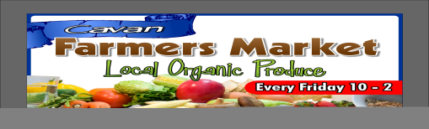

Expression of Interest

To participate as stall holder at Cavan Farmers’ Market at the Townhall Car Park, Townhall Street, Cavan

Name_____________________________________________________________

Address___________________________________________________________

__________________________________________________________________

__________________________________________________________________

Business Name (if any)_______________________________________________

Brand Name (if Different)_____________________________________________

Telephone__________________________________________________________

Mobile_____________________________________________________________

E-mail_____________________________________________________________

Website____________________________________________________________

Describe your background, e.g. farming, food production etc.

___________________________________________________________________

___________________________________________________________________

Describe your business/potential business

___________________________________________________________________

___________________________________________________________________

Please detail the full range of your products, including any seasonal variations

throughout the year____________________________________________________

____________________________________________________________________

Please list what products you propose to sell at the farmers market (if different from

above)______________________________________________________________

____________________________________________________________________

____________________________________________________________________

How often would you be prepared to participate in the farmer’s market?

Weekly [ ] Less often [ ]

Give details___________________________________________________________

_____________________________________________________________________

Are you registered with the Environmental Health Office

Yes [ ] No [ ]

Do you conform to HACCP and/or any other related hygiene/quality systems?

Yes [ ] No [ ]

Give details___________________________________________________________

_____________________________________________________________________

Thank you for expressing an interest in participating in the Cavan Town Farmers Market.

Please return completed forms to:

Patricia J Smith, Community & Enterprise Department, Cavan County Council, Johnston Central Library, Farnham Street, Cavan, Co. Cavan

Ph 049 4378620

pasmith@cavancoco.ie

Applicants may be placed on a waiting list for any space(s) that may become available.

Declaration:

I hereby confirm that I have read and understood this document. All information given on this form and any supporting material is correct to the best of my knowledge. I agree to Cavan County Council making any necessary enquiries for assessment of this application. Should my application be successful, I will provide a copy of all relevant insurance details.

Signed: _____________________________________________________________

Date: _______________________________________________________________

