Cavan: “It’s Our Space Too”

Thursday 22nd & Friday 23rd June 2017

Castlesaunderson, Belturbet, Co Cavan

BOOKING FORM

Place complete a separate booking form for each person attending including PA’s or family members accompanying conference attendees

(Limited to 1 person accompanying per attendee)

Pre-booking is essential by Friday 9th June at 5.00pm

Name:________________________________________________________________
Contact phone no:_____________________________________________________
E-mail:_______________________________________________________________
Please state if you are a Service User or a Provider:_________________________

Please state in order of preference 1,2, or 3 which workshop you would like to attend (1 being your first preference, 2 your second, and 3 your third). We will do our best to accommodate your first choice depending on demand.

Day 1 Parallel Workshops: Session 1 (Morning)

Day 1 Workshops: Session 1 (11.45am-12.45pm)
Workshop | Order of Preference 1,2 or 3
The Social Model: Focusing on Abilities

Employment & Disability

Accessibility

Day 1 Parallel Workshops: Session 2 (Afternoon)

Workshop | Order of Preference 1,2 or 3
Advocacy

Sports

Public participation

A light lunch will be provided on Day 1 of the conference. Please state if you will be staying for lunch and if you have any special dietary requirements:
Do you require lunch (Yes/No):__________________
Any special dietary requirements?________________________________________
___________________________________________________________________

Day 2 Parallel Workshops: (Morning)

Workshop | Order of Preference 1 or 2
Towards Independent Living

Rights and Disabilities

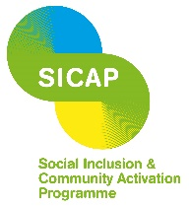
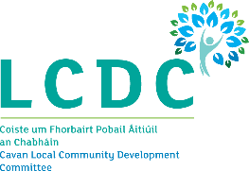
CAVAN DISABILITY NETWORK
In co-operation with Breffni Integrated CLG, Cavan Public Participation Network, and Cavan County Council are delighted to host this event.
Due to limited spaces at the conference pre-booking is essential and on a first come, first served basis.

Please return this completed booking form to Lorraine Mc Teigue at lmcteigue@breffniint.ie or Unit 6a, Corlurgan Business Park, Ballinagh Road, Cavan, Co. Cavan by Friday 9th June 2017 at 5.00pm.
We will confirm all bookings by return email. If you do not receive an email confirming your booking within 3 working days of returning your completed booking form please phone Lorraine on 049 4336070.

