BLACK PIGS DYKE
INTERPRETATION & GRAPHIC DESIGN
TENDER BRIEF
2017
Closing date: Friday 21st March 2017

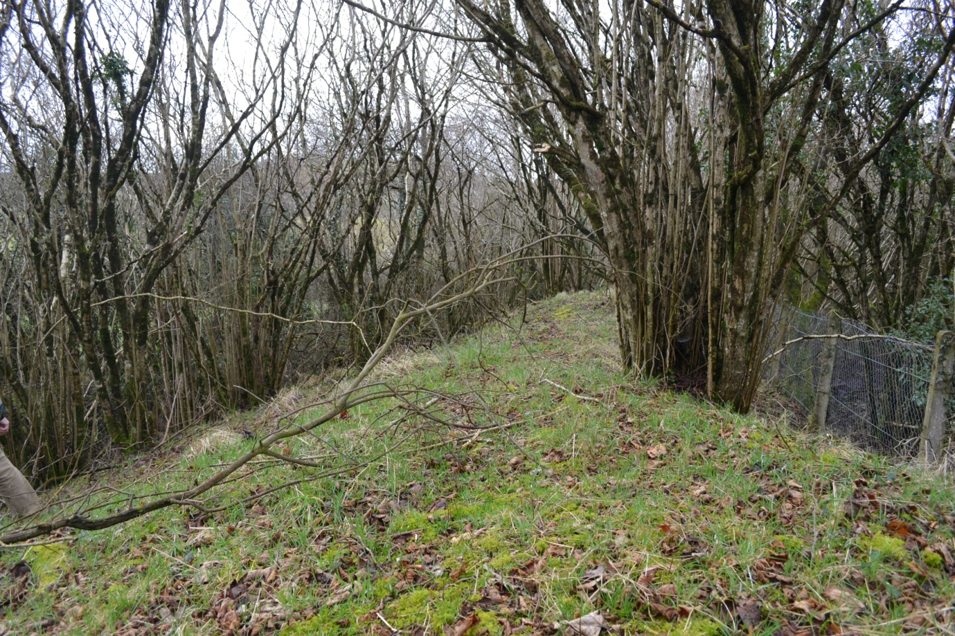
Figure 1 The Black Pig's Dyke, Aghareagh West, Scotshouse, Co.Monaghan

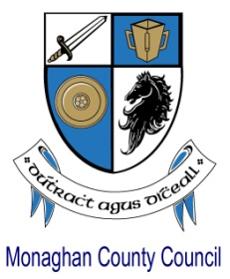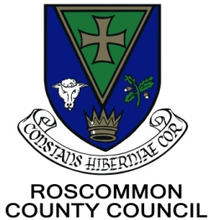

INTRODUCTION TO THE BLACK PIGS DYKE REGIONAL PROJECT
This is joint County Heritage Plan project between Cavan, Leitrim, Longford, Monaghan and Roscommon County Council Heritage Offices, supported by the Heritage Council is ongoing since 2014. Research on the sites across the region is led by the Heritage Officers, and research reports and information are available on our website www.blackpigsdyke.ie
Monaghan County Council is handling procurement on behalf of all the project partners for design services.
Closing date for submission of tenders is 4pm, Friday 21st April 2017. Submissions should be made in writing, envelopes clearly marked with the words Black Pigs Dyke Tender, and addressed to “The Administrative Officer” (or designated alternative), Governance & Corporate Affairs, Monaghan County Council, The Glen, Monaghan.

THE BLACK PIGS DYKE

The extensive lines of large banks-and-ditches known collectively as the Black Pig's Dyke (BPD)
are the amongst the oldest, largest and most celebrated land boundaries in prehistoric Europe.
Yet they are also the most elusive. In the public imagination the diffusely scattered linear
earthworks formed a cohesive and unified boundary for the ancient kingdom of Ulster, a
monumental frontier defence that divided Northern Ireland from the rest of Ireland. The
earthworks are also associated with a widespread folk tradition about a cruel schoolmaster with
magic powers who was transformed by one of his students into a mystical giant black pig and
chased across the countryside, leaving his wake a large track before drowning in a lake.

The linear earthworks were the largest construction projects ever undertaken in prehistoric
Ireland. The social consequences of dyke building must have been enormous. Their monumental scale means they must have been initiatives that were led by those at the apex of society, most probably the same royalty who had the great timber and earth sanctuaries built at places like Tara, Emain Macha, Rathcroghan and the same cohort who had the remarkable timber road at Corlea built in 148 BC.

Huge building projects of dubious practical purpose feature throughout the pre-modern world – Hadrian’s Wall and the Great Wall of China are the most outrageous examples - and were conceived to send clear messages about power, status and respect for authority.

It is suggested that perhaps the linear earthworks were ‘royal works’ that were built in the borderlands as monumental statements of authority, but which had little practical purpose. Ironically, given the enormous societal efforts that would have been required to construct the earthworks, instead of acting to divide early societies the linear earthworks may have been conceived as acts of power that galvanised to unite communities in late prehistoric Ireland.

REQUIREMENTS FOR GRAPHIC DESIGN AND PRINT SERVICES

The five local authorities involved in the project need interpretation materials and information panels to explain and animate the archaeological project and Black Pig’s Dyke cultural sites. For consistency, these materials and panels will be researched and designed as a single project rather than approaching each site on a piecemeal basis.

A logo has already been developed for the project (all files will be made available to the successful company) and a common design style is required to link the panels. Other logos for the individual councils and the Heritage Council will be provided.

The interpretive story at each site will be defined by that site. A visitor exploring the region and coming across panels at different sites should be able to identify that all the interpretation has been carried out as part of the Black Pigs Dyke project through the use of the logo and a certain style.

Project Requirements

The entire interpretive panel project comprises:
- An interpretative plan - Defining, research and copywriting of interpretation content
- Graphic design of the (a) outdoor signage, (b) indoor exhibition panels and (c) DL brochures.
  - One outdoor sign for each county = Five outdoor signs in total
  - Six indoor exhibition panels in total - one relating generally to the Black Pigs Dyke and one specific to each individual county(5).
  - One x DL brochure generic to the overall site
  - Five x DL brochures with county specific information

Each tender should provide for all elements of the project. This may be done in-house or through subcontracting one or more of the tasks to other providers (full details of which must be given in the tender along with samples of their work)

The goal of the interpretation is to improve and enrich the visitor experience by helping site visitors and potential visitors understand the significance of the place they are visiting, and connecting those meanings to visitors' own personal lives. By weaving compelling, thematic stories about the Black Pig’s Dyke, interpreters should aim to provoke visitors to learn and think about their experiences. Effective interpretation enables the visitors to make associations between the information given and their previous perceptions. Interpretation can produce 'Mindful Visitors' who are carefully processing information and negotiating the meanings and significance of the Black Pig’s Dyke and the intangible elements such as the folklore and unknowns.

Defining, research and copywriting of interpretation content

We are looking for an interpretation professional with a body of work of high standard who can research and write copy that will provoke the reader’s attention and interest them in the local black pigs dyke site, and alert them to the regional nature of the project. The writing will accomplish the stated learning, behavioural and emotional objectives for each site.

Graphic design of the outdoor signage, indoor exhibition panels and DL brochures.

The graphic design services must work closely with the interpretation professional to turn the copy into attractive eye catching indoor interpretation panels, outdoor signage and DL brochures. If this part of the project is subcontracted the chosen company must also demonstrate a body of work of high standard, details of which must accompany the tender.

Intellectual property rights of any original GIS mapping, information, photographs and materials will belong to the project team. Files (in a mutually agreed format, to be agreed on consultation) of the illustrations/photographs and finished interpretation panels should be supplied that can be used for other related purposes e.g. leaflets or on our website. Full consents and licences must be obtained for any stock material used.

Project Outputs

The winning company will be required to have regular communications with the project officers by phone and email to manage the progress of the project.

Scope of work

The selected contractor will:
- Conduct an initial focus meeting with project team to determine the main interpretive themes of the sites and the sub-themes of the total interpretive message presentation and the content/focus of the five DL brochures.
- Develop with staff the specific objectives of each interpretive panel, outdoor signage and brochures.
- For each proposed interpretive panel, the designer will develop an interpretive panel planning form that details the individual panels:
- Main interpretive subtheme or message concept
- The specific recommended/approved objectives that individual interpretive panel is to accomplish

c) The best interpretive approach for that panel to accomplish its stated objectives
- The interpretive panel plan and copy written text for the individual panels and brochures will be reviewed by project team and approved before progressing on to the design phase of the project

- The individual interpretive panels will then be graphically designed to accomplish the objectives stated, and draft designs will be reviewed for approval on how well the design addresses the specific objectives. These stage reviews can be by email.
- The same process as above for the (outdoor) signage.
- Working with project staff, review the facility collections for appropriate photographs, or related materials to help illustrate the theme of each interpretive panel (internal sources for images are to be used if they are available and of a suitable quality)
- If images are not available in-house, it will be necessary for the selected contractor to procure these. It is thought that up to a maximum of 50 illustrations and 50 photographs may need to be procured preferably from stock and the selected contractor will have to price these individually on a per picture/per illustration basis up to the maximum. (If fewer than 100 are needed the price paid for the contract will be reduced proportionately). Some illustrations have already been procured for this project
- Provide the final design (based on comments from the review of the draft interpretive panel design) for approval
- Have the client review interpretive panels, outdoor signage and DL brochures for any technical or editorial errors.
- Have the client sign off on the interpretive panel production, outdoor signage and DL brochures after the review. Provide print ready materials for all elements, and versions for use on website.

GUIDANCE FOR SUBMISSION OF TENDERS

Tenders must include a clear outline of the relevant professional skills that would be brought to bear, and the names and CVs of all individuals. The tenderer should also provide three recent examples of previous work outlining all key activities undertaken by individual team members, as well as the relevant contact details of the client.

A detailed method statement should be submitted. This is very important. The method statement should include a breakdown of the duties and time spent by each member of the team and the methods to be used for the work.

A detailed breakdown of estimated costs must be submitted. Please note that the maximum day rate per consultant is €300. Travel expenses should be listed separately.

Extent of professional indemnity and public liability cover must be submitted.

A current Tax Clearance Certificate will be required.

EVALUATION OF PROPOSALS

Each tender will be reviewed to determine if the mandatory Selection Criteria have been met.
Selection Criteria will result in a pass or fail result. Tenders that have passed the selection stage will then be evaluated on Award Criteria. Please ensure that all the information required for the
Selection and Award evaluation is included in your tender.

Selection Criteria
Three examples of previous work should be submitted with the quotation.
Evidence of professional indemnity and public liability cover must be stated in your tender and proof of coverage will be submitted as required on appointment.
A Current Tax Clearance Certificate will be required with the quotation.
Name and CV’s of all individuals as above.

Award Criteria and Scoring
A method statement of no more than five A4 pages in total should be submitted which meets
project specifications, outputs, timescale and budget.

A detailed breakdown of costs must be submitted. Total Net cost of completed project must be submitted with all ancillary costs included as applicable. Total VAT should be stated separately. It is the tenderers’ responsibility to state the correct VAT amount and rate (as applicable). The total price should also be stated inclusive of Net cost and VAT. The tenders received will be scored according to the criteria which are set out below.
Criterion Marks Basis for evaluation
Cost 25% Price quoted (within budget)
Competency and specification of service 25% Provided in your method statement
Deliverables/outputs 25% Provided in your method statement
Project team skills 25% CVs

The award of a score for cost will be computed on an objective mathematical basis, with the lowest price receiving 100% of the available score and all other tenders receiving scores proportionately.
Competency and specification of services, and deliverables/outputs will be assessed from the method statement.

To ensure consistency and equity the evaluation panel will assign scores for quality of response to the qualitative desirable requirements based on the indicative scoring definitions below:

Scoring System Indicator
5 Indicates an excellent response with no weaknesses.
4 Indicates a good response with few weaknesses.
3 Indicates a compliant response but lacks specific information
2 Indicates that the response is limited in detail
1 Indicates there is insufficient detail in response
0 Very limited information provided

This contract will be awarded on the basis of a fixed price contract, and as such, all costs must be submitted as a fixed cost in Euro. No amount over and above the negotiated total contract price amount will be paid to the appointed contractor.
OTHER MATTERS
The payment schedule for the contract will be three staged payments on agreement and completion of each of three key stages to be agreed at the outset.

All invoices and supporting documentation must be submitted by post to Shirley Clerkin, Heritage Officer, Monaghan County Council, The Glen, Monaghan.

The client reserves the right not to accept any of the submissions.
An interim report must be supplied to Monaghan County Council roughly mid-way through the project.
The management team will require a copy of the final draft of the written report for comment and approval prior to completion.
Monaghan County Council operates under the Freedom of Information Act 1997, and all information held by the County Council may be subject to requests under this Act.
Monaghan County Council does not bind itself to accept the lowest or any tender, and no person making a submission will be remunerated for any trouble or expense incurred in preparing a submission.

CONTRACT EVALUATION AND MONITORING
The performance of the appointed service provider will be subject to continuous monitoring, management and review.

INTERPRETATION OF CULTURAL HERITAGE SITES

ICOMOS Charter for the Interpretation and Presentation of Cultural Heritage Sites (known across the world as the "Ename Charter") provides us with seven principles for the interpretation of the Black Pig’s Dyke. These principles form the backbone for the interpretation of the Black Pigs Dyke sites across the region.

Principle 1- Access and Understanding
Interpretation and presentation programmes, in whatever form deemed appropriate and sustainable, should facilitate physical and intellectual access by the public to cultural heritage sites.
Principle 2 - Information Sources
Interpretation and presentation should be based on evidence gathered through accepted scientific and scholarly methods as well as from living cultural traditions.
Principle 3 - Context and setting
The Interpretation and Presentation of cultural heritage sites should relate to their wider social, cultural, historical, and natural contexts and settings.
Principle 4 - Authenticity
The Interpretation and presentation of cultural heritage sites must respect the basic tenets of authenticity in the spirit of the Nara Document (1994).
Principle 5 - Sustainability
The interpretive plan for a cultural heritage site must be sensitive to its natural and cultural environment, with social, financial, and environmental sustainability among its central goals.
Principle 6 - Inclusiveness
The Interpretation and Presentation of cultural heritage sites must be the result of meaningful collaboration between heritage professionals, associated communities, and other stakeholders.
Principle 7 - Research, Evaluation and Training
Continuing research, training, and evaluation are essential components of the interpretation of a cultural heritage site.

