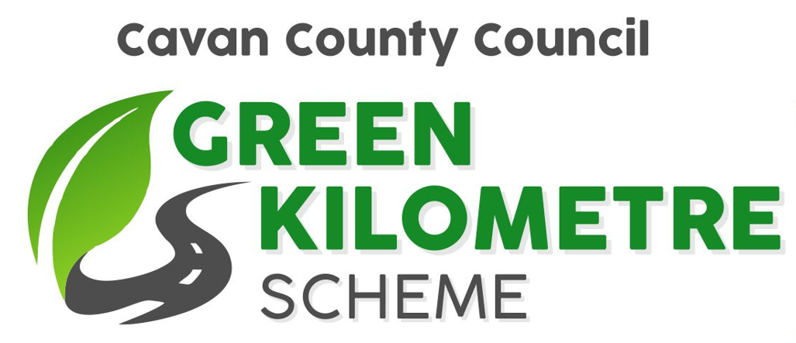

Participation Form

Name of Individual/Group: ______________________________________________

Contact Name: ______________________________________________

Address: ______________________________________________

______________________________________________

______________________________________________

Contact Tel. No.: ______________________________________

Contact Email: ______________________________________

Eircode: ______________________________________

Area where Green Kilometre is located (please use sketch map overleaf and include as much information as possible)

________________________________________________________________________

________________________________________________________________________

________________________________________________________________________

Works planned: (please tick where applicable)

Litter Picking where speed limit does not exceed 50km/h |  | Planting of Native Hedging/Trees |  | Reporting of Illegal Dumping
 |  | Planting of Native Shrubs |  | Record local biodiversity and submit to the National Biodiversity Data Centre https://records.biodiversityireland.ie/start-recording

Sketch map of Green Kilometre Area (must be completed)

Please identify townlands, landmarks, road numbers, Eircodes, etc. to assist our Community Wardens in locating this road (map can be sketched and a scanned/photographed copy can be emailed in addition to this application form to waste@cavancoco.ie)

Litter picking kits

Do you require a litter picking kit? Yes No

If “yes”, please indicate the size of kit required:

kit for me kit for group no. of people in group

Trees (provided as bare root saplings)
Would you like to receive native tree saplings to plant on the kilometre you have adopted as part of the next National Tree Week (March/April each year)?

Yes No

(Species are typically Alder, Common Birch, Oak, Silver Birch, Scots Pine, however species may vary depending on availability).

A limited number of saplings will be available and will be provided on a first come, first served basis.

