# Vision Statement: That Cavan 2020 will be a place that we can be proud of; a place where people can have a good quality of life; a better place to live, to work and to enjoy.

# Chapter 1: Setting & Context

**1.1 Background**

The Local Government Reform Act 2014 provides a stronger and clearer role for local government in economic development and community development which is a key element in achieving the vision set out in the Action Programme for Effective Local Government: “*that local government will be the main vehicle of governance and public service at local level, leading economic, social and community development”.*

One of the key sections of the Local Government Reform Act 2014 provides for the setting up of Local Community Development Committees (LCDC) within each Local Authority who will oversee the development of a 6 year, Local Economic and Community Plan (LECP) for its area. The purpose of the plan is to identify and implement actions to strengthen and develop the economic and community dimensions of the county. The LECP is therefore to be formulated as action focused rather than a high level strategy and encompass delivery programmes by a range of stakeholders. The Plan must also be consistent with current County, Regional, and National strategies and plans.

This plan is to consist of two parts:

* An economic element - to be developed by the Economic Development, Enterprise and Community Strategic Policy Committee (SPC).
* A community element - to be developed by the Local Community Development Committee (LCDC).

The two elements are to be prepared in parallel and adopted by the local authority as a unified plan. This single, integrated economic and community plan will provide the basis for a more coherent, streamlined and co-ordinated approach to service planning and delivery locally.

As a precursor to the development of the LECP a detailed socio economic framework has been prepared. This framework seeks to advise and inform the priority and action areas developed in both the economic and community aspects of the plan. The data has been gathered at both high level and local level and has been analysed across a number of themes:

* Population and Demographics
* Employment and Economic Activity
* Education Training and Skills
* Poverty and Social Exclusion
* Infrastructure and Connectivity

The LECP has been prepared in line with existing policy frameworks at both national regional and local level including reference to the following:

**1.2. EU and National Policies and Plans**

#### EU 2020

Europe 2020 is the EU's ten year growth and job creation strategy that was launched in 2010. The Union has set five ambitious targets to be achieved by the end of 2020. These cover employment; research and development; climate/energy; education; social inclusion and poverty reduction. Each Member State has adopted its own national targets in each of these areas.

* **National Reform Programme**

The National Reform Programme commits Ireland to the high level goals of Europe 2020 and sets out our own national targets under each of the areas.

|  |
| --- |
| **Five targets as laid out in the National Reform Programme for Ireland** |
| 1. **Employment**   69-71% of 20-64 year olds to be employed (currently 64.1%) |
| 1. **R&D/ Innovation**   2.2% of the EU GDP (Public and Private combined) to be invested in R&D/ Innovation |
| 1. **Climate Change/ Energy (currently 2%)**   Greenhouse gas emissions 20% lower than 1990 (-7.6% in 2010)  16% of energy from renewables (6.4% in 2011)  20% increase in energy efficiency |
| 1. **Education**   The share of early school leavers should be below 8% (currently 10.6%)  At least 60% of 30-34 year olds completing third level education (currently 49.4%) |
| 1. **Poverty/ Social Exclusion**   At least 200,000 fewer people experiencing consistent poverty by 2020 (currently 277,000) |

Source: European Commission (2013), “[Ireland’s National Reform Programme 2013 Update](http://ec.europa.eu/europe2020/pdf/nd/prgrep2013_ireland_en.pdf)

#### National Spatial Strategy 2002-2020

The National Spatial Strategy is a 20-year planning framework for all parts of Ireland. It aims to achieve a better balance of social, economic and physical development between regions. Balanced regional development is fundamental to the Programme for Government.

#### National Development Plan (NDP)

Transforming Ireland: A Better Quality of Life for All*.* National Development Plan 2007-2013. This plan was updated in 2010 by Infrastructure Investment Priorities 2010-2016 and National Recovery Plan 2011-2014.

#### Rural Development Plan (LEADER) 2014-2020

Public and stakeholder consultation in relation to Rural Development (CAP Pillar 2) commenced in 2012. The document is currently being developed.

#### Action Plan for Jobs 2014

The Action Plan for Jobs is a whole of government, multi‐annual initiative which mobilises all Government Departments to work towards the objective of supporting job creation.

#### CEDRA Report – Revitalising Rural Economies

The CEDRA report examines strategic initiatives and makes recommendations that will ensure rural areas are able to contribute to the overall national economic growth.

#### National Action Plan for Social Inclusion 2007 – 2016

The National Action Plan for Social Inclusion 2007 – 2016 (NAP inclusion) represents a wide ranging and comprehensive programme of action to address social exclusion.

#### Action Plan for Effective Local Government – Putting People

#### Lakelands & Inland Waterways. Strategic Plan 2010/2015

#### Food Harvest 2020

* **Ireland’s National Strategy to Educe Suicide 2015 – 2020**
* **Better Outcomes Brighter Futures: The National Policy Framework for Children and Young People. 2014-2020**
* **National Drugs Strategy (Interim) 2009 – 2016.**

**1.3 Regional and Local Policies and Plans**

#### Border Regional Authority (BRA) – Regional Planning Guidelines 2010-2022

The BRA Planning Guidelines set out a planning framework for the proper planning and development of the Border Region to ensure sustainable communities for its citizens in the coming years. These regional plans are currently being revised and updated into Regional Economic and Spatial Strategies which will set the long term strategic economic and planning development priorities for the Region

#### Cavan County Development Plan 2014-2020

The current Cavan County Development Plan aims to facilitate the sustainable physical, economic and social development of the county.

#### Cavan County Council’s Corporate Plan 2014-2020

The Corporate Plan 2015-2019 is Cavan County Councils statement of the strategic priorities over the next four to five years and the actions to be taken to deliver on our strategic priorities The six strategic priorities for Cavan Local Authorities to focus on for the future are: 1) Community 2) Economy 3) Environment 4) Infrastructure 5) Interaction 6) Stewardship**.**

#### Cavan Monaghan ETB Education & Training Strategy

#### Cavan Traveller Accommodation Programme

#### Cavan Local Enterprise Plan

Cavan Anti Poverty Social Inclusion Strategy

Cavan Age Friendly Strategy

Cavan Peace III Plan

Cavan Traveller Interagency Plan

Cavan Integration Framework

#### 1.4 County Overview/Profile of the County

Cavan is located in the [Border Region](http://en.wikipedia.org/wiki/Border_Region) on the M3 (N3) north of Dublin. Cavan is bordered by six counties, [Leitrim](http://en.wikipedia.org/wiki/County_Leitrim) to the west, [Fermanagh](http://en.wikipedia.org/wiki/County_Fermanagh) and [Monaghan](http://en.wikipedia.org/wiki/County_Monaghan) to the north, [Meath](http://en.wikipedia.org/wiki/County_Meath) to the south-east, [Longford](http://en.wikipedia.org/wiki/County_Longford) to the south-west and [Westmeath](http://en.wikipedia.org/wiki/County_Westmeath) to the south. Cavan shares a 70 km border with [County Fermanagh](http://en.wikipedia.org/wiki/County_Fermanagh) in [Northern Ireland](http://en.wikipedia.org/wiki/Northern_Ireland) and is the 19th largest of the 32 counties in area and the 8th smallest by population.  The County is characterised by drumlin country side dotted with many lakes and small hills. The North West of the County is sparsely populated and mountainous with many areas of high scenic landscape. The County has a mixed economy with a strong tradition of agriculture production. Food production and processing, craft and manufacturing industries are very important while engineering and new technologies are expanding also. The County is dependent on the road network for transport links. Cavan is served by three National Arterial Routes, the M3, N55 and N16 and is a gateway to and from Dublin, the Midlands and the NorthWest. Cavan Town is a pivotal location on the East West route from Dundalk to Sligo and just in excess of one hour from the M50 ( Dublin) and just under two hours from Belfast

**Chapter 2 Population and Demographics:**

**2.1 Population**

The 2011 population of County Cavan was recorded at 73,183 ( 37,013 males and 36,170 females). The population of the County grew by 14.3% between 2006 and 2011, nearly twice the growth rate for the State at 8.2%. Cavan had one of the highest percentage increases since 2006 of all counties.

Cavan is predominantly a rural county with 70% of the population living in rural areas and very small settlements. There are a number of key urban centres dispersed throughout the county including Cavan Town, Ballyjamesduff, Bailieborough, Virginia, Kinsgcourt and Cootehill

As indicated in table x below, the population growth of the county remains significantly stronger than that of the border region and of the state. Cavan’s Central location within the border region and the location of the county town as well as a number of other towns on national routes mean that the county links most places within the border region. The county also acts as a linkage between the border and other areas nationally as well as linking Northern Ireland with many parts of the south of the Country. Such a strategic location has attracted businesses and industry to the County providing employment. Towns in the east such as Mullagh and Virginia are good locations for people who work in Dublin and Meath to settle because house prices are lower but the journey to work is still manageable. This has led to higher population growth and greater levels of urban development in the east. The west has maintained much of its rural character and with its higher concentration of natural amenities has seen a smaller population growth and correspondingly slower development.

Within the County itself there exists considerable variances in population spread and this has changed considerably in the inter Census period 2006-2011. In 2002 16.8% of people in the County lived in towns this increased to 30% by 2011.

**Table x: County, Border Region and State Population Change 2002-2011**

|  |  |  |  |  |  |
| --- | --- | --- | --- | --- | --- |
| **County, Region or State** | **2002** | **2006** | **% Change** | **2011** | **% Change** |
| **Cavan** | 56,546 | 64,003 | 13.2 | 73,183 | 14.3 |
| **Border Region** | 432,534 | 468,375 | 8.3 | 514,891 | 9.9 |
| **State** | 3,917,203 | 4,239,848 | 8.2 | 4,588,252 | 8.2 |

Source: Census of Population, Volume 1; Population Classified by Area, 2006 and 2011.

Figure xshows the % population changes in Cavan Electoral Division between 2006 and 2011. It is clearly evident that the population of the East of the County continues to grow at a much faster rate than that of the West. One of the biggest challenges we face is continuing to recognise and support the rural nature of the county while at the same time supporting the continued development of our towns and villages.

**Figure x: Percentage of population changes in Cavan Electoral Division between 2006 and 2011.**

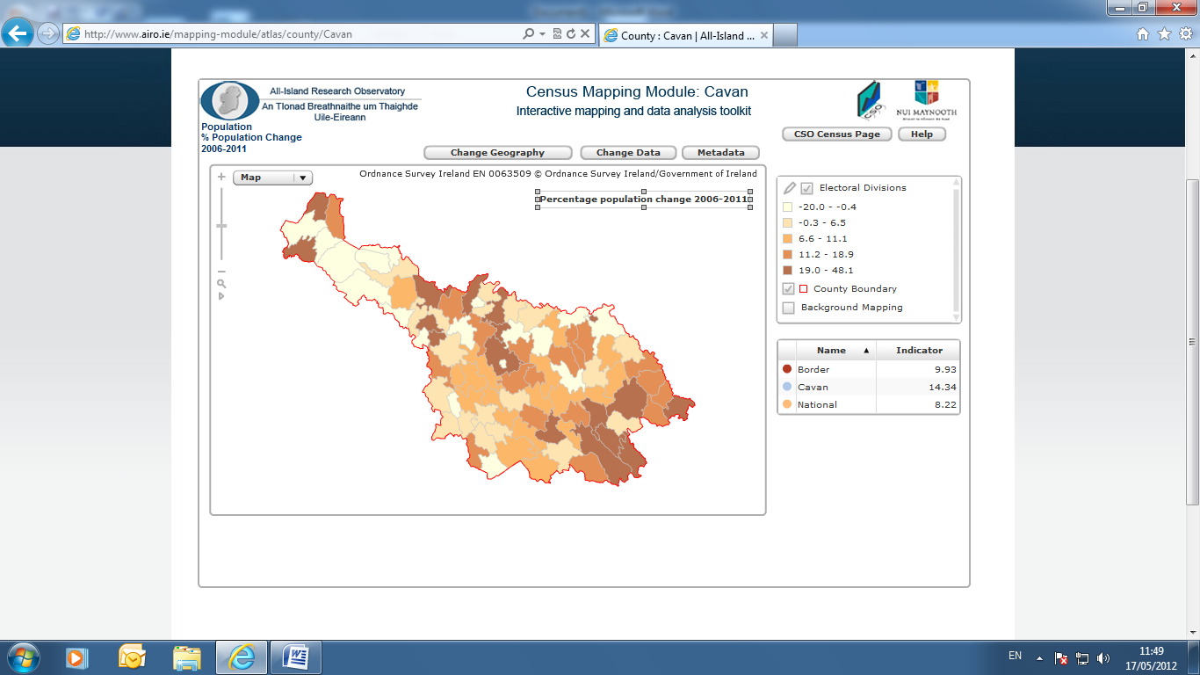Source: AIRO Maynooth

**2.2 Cavan Town**

Cavan Town is the County Town and was one of the five towns to join the ‘large town’ category in the 2011 Census ( i.e. those with a population of 10,000 or more). It is also classified as a Hub town under the National Spatial Strategy and Regional Planning Guidelines. The population of Cavan Town grew by 2,322 people or 29.45% between the two census periods. The population of Cavan Town in 2011 was 10,205 having grown from 7,883 in 2006. Cavan Town is ranked 39 out of 192 towns in Ireland in terms of population size.

**2.3 Age Profile**

The age profile within the County provides a useful picture and indication of the likely future service needs within the County. According to Census 2011 almost a quarter (23.55%) of Cavan’s population are children ( aged 0-14 years) and 12.11% of people are aged 65 years and over:

Table X Age breakdown of Cavan's population, 2002 to 2011

|  |  |  |  |  |  |
| --- | --- | --- | --- | --- | --- |
| **County Cavan** | **2002** | **2006** | **2011** | **Actual change 2006-2011** | **% change 2006-2011** |
| **Total** | 56,546 | 64,003 | 73,183 | 9,180 | 14.34 |
| **0 - 4 years** | 4,189 | 4,743 | 6,177 | 1,434 | 30.23 |
| **5 - 9 years** | 4,143 | 4,914 | 5,529 | 615 | 12.52 |
| **10 - 14 years** | 4,559 | 4,595 | 5,526 | 931 | 20.26 |
| **15 - 19 years** | 4,651 | 4,417 | 4,583 | 166 | 3.76 |
| **20 - 24 years** | 3,719 | 4,326 | 4,106 | -220 | -5.09 |
| **25 - 29 years** | 3,575 | 4,686 | 5,133 | 447 | 9.54 |
| **30 - 34 years** | 3,796 | 4,665 | 5,727 | 1,062 | 22.77 |
| **35 - 39 years** | 3,985 | 4,760 | 5,484 | 724 | 15.21 |
| **40 - 44 years** | 3,936 | 4,567 | 5,286 | 719 | 15.74 |
| **45 - 49 years** | 3,730 | 4,226 | 4,864 | 638 | 15.10 |
| **50 - 54 years** | 3,360 | 3,826 | 4,428 | 602 | 15.73 |
| **55 - 59 years** | 2,911 | 3,497 | 3,950 | 453 | 12.95 |
| **60 - 64 years** | 2,177 | 2,774 | 3,524 | 750 | 27.04 |
| **65 - 69 years** | 2,215 | 2,131 | 2,714 | 583 | 27.36 |
| **70 - 74 years** | 1,907 | 2,018 | 1,990 | -28 | -1.39 |
| **75 - 79 years** | 1,686 | 1,663 | 1,775 | 112 | 6.73 |
| **80 - 84 years** | 1,208 | 1,214 | 1,243 | 29 | 2.39 |
| **85 years and over** | 799 | 981 | 1,144 | 163 | 16.62 |

* the age dependency rate for Cavan at 35.7% is slightly above the national average.

#### 2.4 Population Age Dependency

‘Youth Dependency’ is the percentage of children (0-14) relative to the most economically active age groups (15-64). ‘Old Dependency’ is the proportion of elderly (65+) relative to the 15-64’s. Overall ‘dependency rate’ is the sum of the above two, and is a good indicator of the level of economically dependent population in comparison to the economically active.In 2011, Cavan had a ‘dependency rate’ of 55.42 per cent, which veered towards the higher side when compared with the Border Region (35.4%) and the State (33%)

|  |  |  |  |
| --- | --- | --- | --- |
| **Area** | **% Youth Dependency (0 – 14)** | **% Elderly Dependency**  **(65 & over)** | **% Total Dependency** |
| Cavan | 36.6% | 18.8% | 55.4% |
| Border | 22.6% | 12.6% | 35.2% |
| State | 21.3% | 11.7% | 33% |

Source: Census of Population, 2011

The County has also experienced a large percentage increase in its population of young people in the inter census period 2006-2011. The number of young people aged between 0-4 years increased by 30% and a 20% increase in those aged 10-14 during the same period also.

There are 8,866 people aged 65 and over in Cavan. This figure equates to 12.12% of the population of the county and is higher than the state average of 11.66%.

**2.5 Migration**

Cavan’s population increased by 9,180 people between 2006 and 2011. This increase comprised 5,921 births and net migration of 5,809, less 2,550 deaths. Cavan has a higher than average annual number of births (17.3 per 1,000 population) than the State (16.6) and a higher than average number of deaths (7.4 per 1000 population compared to 6.4). Our net migration rate of 16.9 per 1,000 population was over three times higher than the rate for the State as a whole (5.5).

**Population and Demographics: Key Statistics:**

* The population of the County grew by 14.3% between 2006 and 2011, nearly twice the growth rate for the State 8.2%
* 70% of the population living in rural areas and very small settlements
* In 2002 16.8% of people in the County lived in towns this increased to 30% by 2011
* The population of Cavan Town grew by 2,322 people or 29.45% between 2006 and 2011
* Almost a quarter (23.5%) of Cavan’s population are children ( aged 0-14 years) and 12.11% of people are aged 65 years and over
* Cavan has an age dependency ratio of 55%
* Cavan has a higher than average annual number of births (17.3% per 1000 population) than the State (16.6)

# Chapter 3: Employment and Economic Activity

## 3.1 Unemployment

Census 2011 recorded that the number of unemployed (including first time job seekers) was 7,331 or 21.2 per cent of the total labour force, an increase of 4,810 compared to 2006. The labour force participation rate was 61.9% and the county unemployment rate was 21.2%. At its highest point, the live register showed 7,988 unemployed people (July 2010) but this has been gradually declining (to 5,888 in January 2015).

As can be seen from Table x there has been a very large increase in the number of unemployed males within the county, increasing by 3,290 between 2006 and 2011. Females on the other hand have not experienced such a high rise in unemployment, only increasing by 1,520 in comparison. Male unemployment accounted for 65 per cent of all those unemployed in the county in 2011.

**Table x: The number of unemployed by gender. County Cavan & State, 2006 & 2011.**

|  |  |  |  |  |  |  |  |  |  |  |
| --- | --- | --- | --- | --- | --- | --- | --- | --- | --- | --- |
| **Unemployed** | **Cavan 2006** | | **Cavan 2011** | | **State 2006** | | | **State 2011** | | |
| **No.** | **%** | **No.** | **%** | **No.** | **%** | | **No.** | | **%** |
| **Males** | 1,475 | 58.5 | 4,765 | 65.0 | 106,633 | 59.4 | | 274,327 | | 64.6 |
| **Females** | 1,046 | 41.5 | 2,566 | 35.0 | 72,823 | 40.6 | | 150,516 | | 35.4 |
| **Total** | 2,521 |  | 7,331 |  | 179,456 | |  | 424,843 |  | |

Census 2011 recorded that unemployment rates in certain individual EDs had reached levels well above others within the county. The highest where Belturbet Urban (42.6% male, 28.5% female), followed by Cavan Urban (40.2% male, 29.8% female), Cootehill Urban (35.0% male, 27.0% female), Drumakeever/Derrynananta (28.3% male, 29.2% female) and Bailieborough (30.9% male, 22.6% female). (Trutz Haase & Feline Engling. The 2011 Pobal HP Deprivation Index. February 2013)

**3.2 Live Register**

Data from the ‘Live Register’ though not an official measure of unemployment does provide a valuable short-term trend indicator of unemployment. The Live Register includes part time workers (those who work up to three days a week) seasonal and casual workers entitled to Job Seekers Benefit or Allowance.

The graph below shows the change in live register figures in County Cavan over the last decade. In January 2005, there were just over 2,000 people on the live register in the county. This peaked at 7,462 in January 2011 and has been gradually declining since. In January 2015, there were 5,888 people on the live register in the county.

**Graph xx Live Register figures for County Cavan from January 2005 to 2015**

**(* MO 1 Refers to January of year in question)**

**3.3 Youth on the Live Register**

The below Tables XX shows those under 25 years of age by gender and duration on the Live Register for the two Social Welfare offices within County Cavan as of February 2015.

Table xx a): Cavan Intreo Office - Live Register Figures (February 2015)

|  |  |  |  |
| --- | --- | --- | --- |
| **Live Register** | **Male** | **Female** | **Total** |
| **<3 months** | 79 | 58 | 137 |
| **3-6 months** | 71 | 66 | 137 |
| **6-12 months** | 75 | 74 | 149 |
| **1-2 years** | 75 | 87 | 162 |
| **2-3 years** | 43 | 40 | 83 |
| **>3 years** | 52 | 51 | 103 |
| **Total** | 395 | 376 | 771 |
|  | 51.23% | 48.77% | 100% |

Table xx b):Ballyconnell Intreo Office - Live Register Figures (February 2015)

|  |  |  |  |
| --- | --- | --- | --- |
| **Live Register** | **Male** | **Female** | **Total** |
| **<3 months** | 17 | 10 | 27 |
| **3-6 months** | 17 | 8 | 25 |
| **6-12 months** | 16 | 8 | 24 |
| **1-2 years** | 23 | 11 | 34 |
| **2-3 years** | 10 | 7 | 17 |
| **>3 years** | 13 | 14 | 27 |
| **Total** | 96 | 58 | 154 |
|  | 62.34% | 37.66% | 100% |

As from February 2015,16.55 per cent of all those on the live register are under 25 years of age and the majority of these are male (53.08%).

**Population and Demographics: Key Statistics:**

* Census 2011 recorded that the number of unemployed was 7,331 or 21.2 per cent of the total labour force, an increase of 4,810 compared to 2006.
* Male unemployment accounted for 65 per cent of all those unemployed in the county in 2011.
* In 2011 the highest unemployment rates in Cavan where in Belturbet Urban (42.6% male, 28.5% female), followed by Cavan Urban (40.2% male, 29.8% female).
* In January 2015, there were 5,888 people on the live register in the county.
* As from February 2015,16.55 per cent of all those on the live register are under 25 years of age and the majority of these are male (53.08%).

**3.4 Economic Activity**

County Cavan has a strong manufacturing and agricultural background, although Professional Services and Commerce and Trade are now the largest sectors. Cavan’s industry base relies on a mix of indigenous businesses and some Foreign Direct Investment [FDI] companies. In 2012 there were 3,056 VAT registered firms in County Cavan. There are several significant employers, and over 80 companies supported by Enterprise Ireland.

The Border Regional Planning Guidelines 2010-2022 set out the existing and potential areas for future growth and development in the region. It outlines the key sectors as being: agri-food, internationally traded services, renewable energy, life sciences, tourism, natural resources, creative, caring and retail. Previous studies at a local level set out strategy for development of County Cavan’s economy to be focused on increased innovation and research as the way forward.

The Cavan County Development Plan 2012-2020 outlines the Local Authority’s key objectives and commitments in relation to the following areas:

* Agriculture & Farm Diversification – recognising that agriculture would continue to be a crucial driver in the local economy, and its significant contribution to employment it outlined the Local Authority’s commitment to supporting agricultural employment in the county and also farm diversification which could lead to new employment opportunities.
* Enterprise Development in Urban Areas – including the facilitation of new industrial development in serviced towns and villages
* Rural Enterprises –Support highlighted for suitable small scale enterprises in rural locations noting the potential they had for contributing to the economy of such areas.
* E-working, Teleworking, and home based economic activity in rural areas – the ongoing change in work patterns was noted in this area and in particular the necessity to embrace such change as a real alternative to commuting as long as it did not negatively affect the residential character of any area.
* Extractive industries – the potential for development in this area was noted but that it at all times needed to be balanced with the protection of the built and natural heritage of the county.
* Forestry – Socio-economic benefits to the county from appropriately located and well managed developments relating to this sector.
* Retail – the plan recognised that the retail sector was an important employer and driver of economic growth and the aim was to sustain and improve the retail profile and competiveness of the county through the consolidation and enhancement of town centres and settlements and by improving the quality and choice of retail developments on offer.

## 3.5 Industry in Cavan

Census 2011 showed that over 11,000 people are employed in the two largest sectors in the county (Professional services and Commerce and Trade), although Manufacturing and Agriculture are still very significant players.

Table x Persons at work by industry in County Cavan, 2011

|  |  |
| --- | --- |
| **Industry in Cavan** | **Number of people** |
| Professional services | 5,714 |
| Commerce and trade | 5,615 |
| Manufacturing industries | 4,206 |
| Other | 3,792 |
| Agriculture, forestry and fishing | 3,348 |
| Building and construction | 1,695 |
| Public administration | 1,646 |
| Transport and communications | 1,293 |
| **Total** | **27,309** |

A more detailed breakdown of this data can be seen in Table x which shows the increase or decrease in the number of people at work in particular sectors over three Census periods. For instance, employment in manufacturing industries has remained fairly stable since 2002, while there has been a huge drop in numbers employed in construction. Other sectors that experienced an increase in workers include hotels and restaurants, wholesale and retail trade, real estate, public administration and defence, and education. Numbers employed in health and social work have increased by 38% between 2002 and 2011.

|  |  |  |  |
| --- | --- | --- | --- |
| Table x Population Aged 15 Years and Over at Work (Number) in County Cavan by Broad Industrial Group and Census Year | | | |
| **Cavan** | **2002** | **2006** | **2011** |
| Agriculture, forestry and fishing | 3,367 | 2,740 | 3,381 |
| Mining, quarrying and turf production | 142 | 192 | 122 |
| Manufacturing industries | 4,008 | 4,406 | 3,928 |
| Electricity, gas and water supply | 102 | 115 | 158 |
| Construction | 2,569 | 4,082 | 1,765 |
| Wholesale and retail trade | 2,695 | 3,596 | 3,758 |
| Hotels and restaurants | 1,023 | 1,321 | 1,418 |
| Transport, storage and communications | 823 | 1,003 | 1,054 |
| Banking and financial services | 738 | 1,047 | 953 |
| Real estate, renting and business activities | 956 | 1,370 | 1,478 |
| Public administration and defence | 1,245 | 1,348 | 1,632 |
| Education | 1,174 | 1,472 | 2,172 |
| Health and social work | 1,831 | 2,634 | 3,000 |
| Other community, social and personal service activities | 580 | 793 | 973 |
| Industry not stated | 1,161 | 2,200 | 1,517 |
| **Total at work** | **22,414** | **28,319** | **27,309** |

CSO data indicate that there were 2,877 ‘active enterprises’ registered in County Cavan in 2012, of which 738 were wholesale and retail trade, 669 were construction and 309 were accommodation and food services.

|  |  |
| --- | --- |
| **Table x Active Enterprises (Number) in County Cavan, Activity, 2012** | |
|  | **2012** |
| **Cavan** |  |
| Manufacturing (C) | 211 |
| Electricity, gas, steam and air conditioning supply (D) | .. |
| Water supply, sewerage, waste management and remediation activities (E) | 30 |
| Construction (F) | 669 |
| Wholesale and retail trade, repair of motor vehicles and motorcycles (G) | 738 |
| Transportation and storage (H) | 181 |
| Accommodation and food service activities (I) | 309 |
| Information and communication (J) | 49 |
| Financial and insurance activities excluding activities of holding companies (K-642) | .. |
| Real estate activities (L) | 140 |
| Professional, scientific and technical activities (M) | 258 |
| Administrative and support service activities (N) | 138 |
| Education (P) | 110 |
| ICT total (261 to 264,268,465,582,61,62,631,951) | 44 |
|  |  |
| The county breakdown is based on the address at which an enterprise is registered for Revenue purposes, rather than where the business actually operates from, because no comprehensive administrative source is currently available for business locations. In particular, where an enterprise has local units in several counties, but one head office where all employment is registered, all its employees will be counted against the county where the head office is located. | |

## 3.6 Larger Employers in Cavan

According to the Forfas annual employment survey (October 2013), Enterprise Ireland has close to 80 client companies in Cavan directly employing 3,800 people. Some of the larger Enterprise Ireland clients in terms of numbers employed include Carton Bros, Kingspan, Lakeland Dairies, Liffey Meats, Obelisk, Quinn Packaging and Quinn Cement, McCarrens/Kepak etc. There are a number of FDI companies in Cavan including CG Power Systems, Wellman International, Liberty Insurance, Abbott Nutrition, Gypsum Industries and Boxmore Plastics, PreSonus, Global Indemnity and Foamalite.

***Notable employers in County Cavan are listed in Appendix xxxx. Sectors include food processing, insulation / other construction products, engineering and financial services.***

## 3.7 Indigenous Sector

Cavan is heavily dependent on indigenous development as a source of wealth and job creation. The county is renowned for its achievements in the building and building materials sectors, as well as engineering and added value food production. Achievements to-date by the County’s key companies clearly illustrate that Cavan has a number of high quality entrepreneurs.

**3.8 Food Production**

Cavan has a proud tradition in agricultural production and the ready supply of local quality primary produce has spawned the growth of food businesses across the county. Lakeland Dairies is Ireland’s second largest dairy processing co-operative, processing about one billion litres of milk annually into a range of value added dairy foodservice products and food ingredients, exporting to 70 countries worldwide. Glanbia plc is an international nutritional solutions and cheese group, headquartered in Ireland with one of its production facilities, Glanbia Ingredients, based in Virginia, Co. Cavan.

Artisan food production continues to grow with local producers making quality speciality foods for domestic and international markets. Cavan food producers are at the forefront of innovative food processing techniques engaging with all local and national support agencies and the third level sector.

**3.9 Engineering**

Cavan has a long established reputation for engineered products produced to meet the exacting needs of an international client base. From precision engineering companies, to process control systems designers, to the latest in agricultural machinery, and machine tools, Cavan companies are forging ahead to provide innovative engineering solutions to grow and sustain their business and that of their clients. **Key examples include PQE Ltd., Mastek Ltd., EMCA Ltd., Sean Brady Engineering Ltd. and Multi-Tech Design Ltd.**

**3.10 Building Materials / Insulation Products / Green Technologies**

International leaders in the building materials industry (including insulation products) are located in the county. The Kingspan Group, headquartered in Kingscourt, County Cavan, are a world leading manufacturer of sustainable products for the construction industry. Quinn Industrial Holdings Ltd is a leading group in a range of building products and packaging. Other established building products companies that are expanding their reach into global markets include Airpacks Ltd, O’Reilly Bros Ltd., and Ballytherm Ltd.

**3.11 Financial, ICT and Tradable Services Sectors**

There is evidence of a growing financial and internationally trading services sector, offering potential for economic diversification and job creation. Additionally the digital economy is at an early stage of development and could offer strong opportunities into the future.

**Examples of some of the key Irish owned industries located in the County include:**

* Lakeland Dairies (dairy products) - [www.lakeland.ie](http://www.lakeland.ie/)
* Glanbia (dairy products) - [www.glanbia.ie](http://www.glanbia.ie/)
* Kingspan Group (insulated panels) [www.kingspan.com](http://www.kingspan.com/)
* Liffey Meats (meat processing) [www.liffeymeats.ie](http://www.liffeymeats.ie/)
* Carton Bros (poultry products) [www.cartongroup.ie](http://www.cartongroup.ie/)
* Quinn Industrial Holdings Ltd (packaging & building materials etc.)

[www.quinn-buildingproducts.com](http://www.quinn-buildingproducts.com)

* Foamalite (PVC foam sheeting) [www.foamalite.ie](http://www.foamalite.ie/)
* Abcon (industrial abrasives ) [www.abconireland.com](http://www.abconireland.com)
* ATA Group (industrial tools) [www.atagroup.ie](http://www.atagroup.ie)
* Obelisk Communications (telecoms services) [www.obelisk.com](http://www.obelisk.com)
* FSW Coatings (paint manufacture) [www.fleetwood.ie](http://www.fleetwood.ie)
* McCarren & Co Ltd (processes pork and bacon products) [www.kepak.com](http://www.kepak.com)

### 3.12 Commerce and Trade / Professional Services & Retail Services

As mentioned previously Census 2011 showed that over 11,000 people are employed in the two largest sectors in the county (Professional services and Commerce and Trade). The CSO category of Commerce and Trade includes wholesale and retail trade, banking and financial services and real estate, renting and business activities.

The retail sector is an important employer and driver of economic growth in the County and contributes to the vitality of our towns, especially Cavan Town. In 2012 Cavan’s retail sector employed 2,083 people in 738 active retail enterprises.

Table x Retail firms in County Cavan, 2011

|  |  |  |  |  |  |  |  |
| --- | --- | --- | --- | --- | --- | --- | --- |
| **Area** | **No. of Retail* Firms 2011** | **Total Firms**  **2011** | **No. of Retail* Firms 2012** | **Total Firms 2012** | **Reduction in Retail* Firms 2011-2012** | | **Reduction in Total Firms 2011 – 2012** |
| **Cavan** | 750 | 2,882 | 738 | 2,773 | -12 | -1.6% | -3.8% |
| **State** | 42,966 | 189,055 | 42,210 | 185,530 | -756 | -1.9% | -1.9% |

* Category includes ‘retail, wholesale and repair of motor vehicles / motor trades’ **Area**

Source: CSO, Central Business Register

[http://www.cso.ie/px/pxeirestat/Statire/SelectVarVal/Define.asp?maintable=BRA18&PLanguageCavan 2](http://www.cso.ie/px/pxeirestat/Statire/SelectVarVal/Define.asp?maintable=BRA18&PLanguageCavan%202), 144 67

The current County Retail Strategy covers the period 2008 to 2014 and contains general requirements for retail development. ‘Retail Planning Guidelines’ where issued by the DECLG in April 2012 and, on foot of this, an up-to-date retail strategy is required for the County.

**3.13 Enterprise Space/Parks**

A number of community enterprise centres have been developed across the County. Cavan County Enterprise Fund (CCEF) manages centres at Killygarry (Cavan), Cootehill, and Blacklion. The latest addition is a new 14,000 sq ft. high specification enterprise and technology centre in Cootehill. Other community managed enterprise centres are located at Bailieborough and Kingscourt.

IDA Ireland has developed and retains a 37 acre (15 hectare) business park at Killygarry, Cavan. Cavan County Council own industrial lands at Cornacarrow, Cootehill and Burrencarragh, Virginia. Cavan County Enterprise Fund owns land at Blacklion and Cootehill.

**3.14 Local Enterprise Office**

The Local Enterprise Office Cavan was established in April 2014 and combines the expertise, knowledge and experience of the former Cavan County Enterprise Board and the Business Support/Economic Development Unit of Cavan County Council.

It provides a comprehensive information, advisory, and support service to new and existing entrepreneurs on all aspects of setting up and running a business.

The LEO serves as a “first stop shop” to provide support and services for those interested in starting, growing, and developing a business in Co. Cavan. The office also acts as an information source and referral point for all state enterprise agencies, and government initiatives, providing information on all aspects of business, including enterprise incentives, business structures, taxation, regulatory obligations, workspace, market research, planning etc.

Services provided to entrepreneurs/existing businesses include:

* Promotion of entrepreneurship / self employment
* Provision of business information & advice
* Business skills training
* Mentoring Service
* Financial assistance
* Management Development Programmes
* Cross Border and All Island Trade Programmes
* Networking Opportunities

The Local Enterprise Office also spearheads various initiatives to encourage and promote enterprise across the county working with business groups, community groups, schools, as well as various other local and national bodies.

The vision of Cavan LEO is to make Cavan one of the most enterprise friendly, and enterprise supportive locations in Ireland, maximising the number of new start-up and expanding businesses across the county, maximising employment potential through creation of new sustainable jobs, retention of existing employment, and overall contributing to the development of a vibrant local economy.

### 3.15 Tourism

Cavan attracts significant numbers of overseas visitors and the county’s performance compared to neighbouring counties is good. Cavan is the third most popular County ( after Donegal and Sligo) for overseas visitors in the North West of the Country.

Table x: Overseas visitors (000s) to counties in 2012

|  |  |  |  |  |  |
| --- | --- | --- | --- | --- | --- |
| **County** | **Total** | **Britain** | **Mainland Europe** | **North**  **America** | **Other**  **Areas** |
| Cavan | 80 | 51 | 9 | 16 | 4 |
| Donegal | 174 | 64 | 65 | 35 | 10 |
| Leitrim | 29 | 21 | 5 | 4 | * |
| Monaghan | 46 | 32 | 7 | 5 | 2 |
| Louth | 92 | 46 | 25 | 11 | 10 |
| Sligo | 129 | 44 | 47 | 26 | 12 |

*Indicates less than 1,000

However, compared with other areas of the country, Cavan and the border region in general, are weaker with regard to tourism numbers and spend. Domestic tourism figures show that the Border region had 772k visitors in 2013, much lower numbers than the West (1168k) or South West (1411k)

**Table xx: Domestic Travel by Irish Residents by Region Visited and Year**

|  |  |  |  |  |
| --- | --- | --- | --- | --- |
| **Number of Trips by Irish Residents on Domestic Travel (Thousand)** | **2010** | **2011** | **2012** | **2013** |
| State | 7300 | 7169 | 7031 | 7111 |
| Border, Midland and Western | 2302 | 2102 | 2124 | 2256 |
| Border | 827 | 729 | 711 | 772 |
| Midland | 223 | 284 | 329 | 316 |
| West | 1253 | 1089 | 1084 | 1168 |
| Southern and Eastern | 4998 | 5067 | 4907 | 4855 |
| Dublin | 1116 | 1279 | 1392 | 1344 |
| Mid-East | 369 | 503 | 463 | 487 |
| Mid-West | 754 | 692 | 659 | 655 |
| South-East | 1136 | 1101 | 991 | 957 |
| South-West | 1622 | 1493 | 1403 | 1411 |

Source: www.cso.ie

Although there are strong tourism products here, the county lacks a significant ‘honeypot’ attraction. The opening of the new interpretative centre and walking trails in 2014 in the Cavan Burren is a very positive development. 6,817 vehicles were recorded as going into the Burren between April 2014 and November 2014. Since its opening there has been a positive increase in the numbers visiting the other local attractions around the area also, such as the Shannon Pot with 10,392 pedestrians counted visiting this attraction in 2014.

Cavan is known as angling country with its well-stocked waters attracting German, French and English anglers for decades. The angling market represents approximately 30% of all overseas visitors to County Cavan, and is particularly important to rural B&B and self-catering accommodation provider. Alternative recreational uses of the waterways have been on the increase for a number of years now, in particular, the waterways throughout the Lough Oughter lake system – a protected landscape of interlocking lakes rich in biodiversity. Canoeing and kayaking on the waterways is increasingly popular with hundreds of school groups, families, canoe clubs and other visitors hiring canoes and kayaks at Cavan Canoe Centre near Butlersbridge every year.

In recent years, initiatives such as the annual ‘Taste of Cavan’ food event (35,000 visitors over two days)  and the opening of the new international scouting centre at Castle Saunderson (22,000 bednights in 2014)  and Cavan Walking Festival (1,000 walkers across ten days in May) have contributed to the expansion of the local tourism product offering.

In 2014, Cavan County Council won a World Responsible Tourism Award in the category ‘Best of People with Disabilities’. Multi-access trails are in place across the county and key visitor attractions such as Cavan Burren Park and the County Museum are designed with accessibility in mind. Cavan is also unique in Ireland in delivering online access guides to public buildings and spaces across the county ([www.disabledgo.com](http://www.disabledgo.com)).

### 

### 3.16 Agriculture

Traditionally the economy of the county has been driven by agriculture and agriculture related activities, much of our history and cultural identity is connected with farming and rural areas. The CSO identifies Cavan as one of the counties most reliant on employment in agriculture, forestry and fishing, along with Monaghan and South Tipperary, with 1 in 8 workers in the sector. According to the Census of Agriculture taken in 2010, there were 5,282 farms in County Cavan, with the largest numbers concentrating on specialist beef production followed by specialist dairying (593). The pig industry is very significant in Cavan. More than one fifth of pigs in the country are in Cavan (332,880 pigs) where the average number of pigs per farm is 4,059. Pig farming is an intensive activity carried out by a small number of specialised producers. A total of 4,666 farms in Cavan had cattle in 2010 (219,463 animals) and 270 farms had poultry.

Table x Number of farms in County Cavan by farm type

|  |  |  |  |  |  |  |  |  |
| --- | --- | --- | --- | --- | --- | --- | --- | --- |
| **Specialist**  **tillage** | **Specialist dairying** | **Specialist beef production** | **Specialist sheep** | **Mixed grazing live-stock** | **Mixed crops and live-stock** | **Mixed field crops** | **Other** | **Total** |
| 6 | 593 | 3,685 | 212 | 378 | 9 | 288 | 111 | 5,282 |

Source: Census of Agriculture, 2010

Table x below displays the number of farms, average farm size and the number of people employed on farms in 2010. It also provides a comparison on how the sector has changed over the 10 year period from 2000**.** It shows that even though the average number of farms have decreased over this period (-209), employment levels have increased (+442), along with the average farm size.

Table x Analysis of Agriculture Sector in Cavan 2000 & 2010

|  |  |  |  |  |  |
| --- | --- | --- | --- | --- | --- |
| **No. of Farms** | | **Average Farm Size**  **(ha)** | | **Employment in**  **Agriculture** | |
| **2000** | **2010** | **2000** | **2010** | **2000** | **2010** |
| 5,491 | 5,282 | 25.2 | 26.4 | 9,457 | 9,899 |

Source: Census of Agriculture, 2010

The average standard output of farms in Cavan is €34,528 (standard output is the average monetary value of the agricultural output at farm-gate prices). Only five per cent of the county’s farms generated a standard output in excess of €100,000 in 2010.

It is widely acknowledged that Agriculture will be a crucial driver in restoring Ireland’s economic growth and creating employment over the next number of years, particularly in the food processing areas. Initiatives need to be supported which promote agricultural employment in the county whilst the agricultural sector undergoes challenges posed by modernisation, restructuring, market development and the increasing importance of environmental issues.

**3.17 Farm Diversification**

There is a need to promote farm diversification and new employment opportunities within the agriculture sector in order to sustain rural communities and ensure the viability of existing community services. Diversification of the rural economy and in particular developing the potential of the agri food sector, forestry, the sustainable exploitation of natural resources and alternatives to on farm and off farm activities are all to be encouraged.

Such development initiatives can provide additional or alternative incomes that supplement declining incomes from agricultural outputs. According the County Development Plan 2014-2020, diversification will be facilitated, provided the proposal is related directly either to the agricultural operation engaged upon the farm or the rural nature of the area; does not have unacceptably negative impacts on the landscape and character of the area and is compatible with the existing road infrastructure in the area.

**Economic Activity: Key Statistics:**

* There are 3,056 VAT registered firms in Cavan (2012). There are almost 80 companies supported by Enterprise Ireland.
* Census 2011 showed that over 11,000 people are employed in the two largest sectors in the county (Professional services and Commerce and Trade).
* Numbers employed in health and social work have increased by 38% between 2002 and 2011.
* There were 2,877 ‘active enterprises’ registered in County Cavan in 2012, of which 738 were wholesale and retail trade, 669 were construction and 309 were accommodation and food services.
* In 2012 Cavan’s retail sector employed 2,083 people in 738 active retail enterprises.
* Cavan is the third most popular County (after Donegal and Sligo) for overseas visitors in the North West of the Country.
* The angling market represents approximately 30% of all overseas visitors to County Cavan.
* Cavan is highly reliant on employment in agriculture, forestry and fishing.
* The average standard output of farms in Cavan is €34,528 (standard output is the average monetary value of the agricultural output at farm-gate prices).
* According to the Census of Agriculture taken in 2010, there were 5,282 farms in County Cavan, with the largest numbers concentrating on specialist beef production followed by specialist dairying (593)
* Between 2000 and 2010 the average number of farms in the County decreased by 209 however employment levels have increased by 442 along with the average farm size.

**Chapter 4: Education, Training & Skills**

**4.1 Overview**

The provision of lifelong education services and facilities is an important factor in creating sustainable communities and ensuring equal access to employment. Responsibility for the provision of National, Post Primary School and Third Level education in Cavan County lies with the Department of Education and Science. In addition to the latter, facilities such as Youthreach services, adult education and literacy promotion and further education courses are available throughout the county.

The establishment of the new Cavan Monaghan Education and Training Board (CMETB), and SOLAS, has created the potential for a more streamlined and co-ordinated approach to the local delivery of education and training in the county. Joint collaborative planning and partnership arrangements are underway which should ensure a better quality service provision.

Cavan Institute (the largest PLC college outside Dublin and Cork) offers a wide range of courses to students across multi disciplinary topics. These include courses covering Accountancy, Business, Law, Computing, Engineering, Built Environment, Hotel & Catering.

Cavan also offers ready access to 3rd level education at the Dundalk, Athlone, Sligo, and Blanchardstown Institutes of Technology, as well as universities on an all island basis.

Cavan Innovation & Technology Centre (CITC) was established in 2002 as a distance learning/outreach centre and corporate training facility. CITC has partnered with a number of Ireland’s leading academic institutions to improve access to third level education, particularly for the business community.

**4.2 Education Attainment**

Of those aged 15 years and over living within the County whose full-time education had ceased, 20.6 per cent were educated to at most primary level only; a further 57.3 per cent attained second level while 22.2 per cent were educated to third level.

Throughout Ireland there has been a continuous improvement in the level of education amongst the adult population over the past 20 years. In 1991, 36.7% of the adult population had primary education only. This dropped to half that level (18.9%) in 2006 and even further to 16.0% in 2011. Between 2006 and 2011 the adult population with primary education only decreased by 2.9 percentage points. The rate for County Cavan has fallen from 46.7% in 1991, to 25.6% in 2006 and 20.6% in 2011, which is about 5 percentage points more than the nationally average change.

However, despite the considerable improvement at county level, there remain several rural EDs where still considerable parts of the adult population have primary education only. These are Diamond (34.0%), Drumakeever/Derrynananta (33.6%), Templeport/Benbrack (32.3%) and Canningstown (32.1%), all of which are characterised by levels of adults with primary education only at least twice as high as the national average.

**Figure xx: Percentage of persons aged 15 years and over by highest education completed. Primary Level only. County Cavan, 2011.**

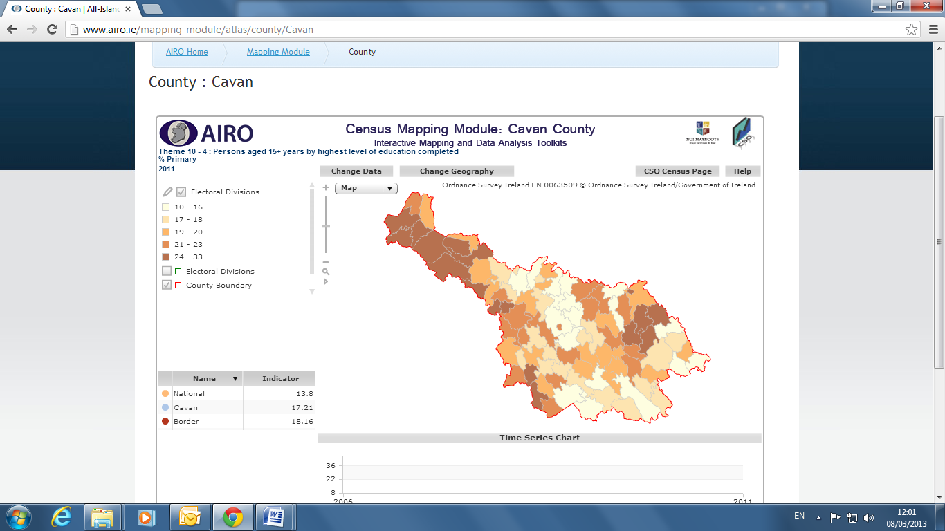

Source: All Island Research Observatory (AIRO) Maynooth

Table xx breaks down those whose full time education has ceased by highest level of education completed. Females tend to dominate those in the higher or further education fields apart from the Apprenticeship andDoctorate (Ph.D) levels.

**Table x: Population aged 15 years and over by gender, whose full time education has ceased by highest level of education completed. County Cavan, 2011.**

|  |  |  |  |
| --- | --- | --- | --- |
| **Highest Education Level** | **Males** | **Females** | **Total County Cavan** |
| No formal education | 621 | 419 | 1,040 |
| Primary | 4,761 | 3,409 | 8,170 |
| Lower Secondary | 5,167 | 3,695 | 8,862 |
| Upper secondary | 3,893 | 4,779 | 8,672 |
| Technical/vocational | 2,244 | 2,560 | 4,804 |
| Advanced certificate/completed apprenticeship | 2,149 | 1,123 | 3,272 |
| Higher certificate | 778 | 1,211 | 1,989 |
| Ordinary bachelor degree/ professional qualification or both | 1,144 | 1,633 | 2,777 |
| Honours bachelor degree/professional qualification or both | 1,134 | 1,897 | 3,031 |
| Postgraduate diploma or degree | 712 | 1,294 | 2,006 |
| Doctorate (Ph.D) | 56 | 50 | 106 |
| Not Stated | 1,356 | 1,388 | 2,747 |
| **Total** | **24,018** | **23,458** | **47,476** |

**4.3 Third level qualification**

The proportion of County Cavan’s population with a third level qualification has grown from 8.3 per cent in 1991, to 23.3 per cent in 2006 and marginally decreased to 22.2 per cent in 2011. However, this 20 year growth is well below that which occurred nationally, 13.9 percentage points compared to 17.6 percentage points nationally. (Trutz Haase & Feline Engling. The 2011 Pobal HP Deprivation Index. February 2013)

‘Social sciences, business and law’ are the most common areas of studies for people within the county to complete their third level qualification in as Table xx indicates.

**Table xx:** **Population aged 15 Years & over with a third level qualification. County Cavan. 2011.**

|  |  |
| --- | --- |
| **Third Level Qualification** | **Number** |
| Social sciences, business and law | 2,810 |
| Health & welfare | 1,951 |
| Education & teacher training | 1,538 |
| Engineering, manufacturing & construction | 1,345 |
| Nursing & caring | 952 |
| Science , mathematics & computing | 918 |
| Business & administration (broad programmes) | 719 |
| Not Stated (including unknown) | 631 |
| Accounting & taxation | 563 |
| Other social sciences, business and law subjects | 515 |
| Humanities | 506 |
| Personal services | 500 |
| Other health & welfare | 439 |
| Agriculture & veterinary | 380 |
| Arts | 351 |
| Management & administration | 350 |
| Building & civil engineering | 309 |
| Engineering and engineering trades (broad programmes) | 304 |
| Social work & counselling | 278 |
| Computer use | 271 |
| Other humanities | 270 |
| Physical sciences (physics, chemistry, earth science) | 269 |
| Law | 237 |
| Architecture & town planning | 237 |
| Crop & livestock production | 234 |
| Other engineering, manufacture & construction | 232 |
| Medicine | 200 |
| Hotel, restaurant & catering | 189 |
| Other personal services | 157 |
| Hair & beauty services | 154 |
| Other agriculture & veterinary | 146 |
| Computer science | 145 |
| Security services (includes police & fire services) | 139 |
| Marketing & advertising | 132 |
| Electricity & energy | 119 |
| Other science, mathematics & computing | 117 |
| Biology & biochemestry | 116 |
| Secretarial & office work | 109 |
| Audio-visual techniques & media production | 107 |
| Psychology | 100 |
| Design | 92 |
| Mechanics and metalwork | 92 |
| Mother tongue | 89 |
| History & archaeology | 89 |
| Economics | 85 |
| Child care & youth services | 82 |
| Music & performing arts | 77 |
| Other arts | 75 |
| Foreign languages | 58 |
| Motor vehicles, ships & aircraft | 52 |
| Transport services | 34 |
| Other subjects | 32 |

At electoral division level, and again mirroring the situation with regard to the higher incidences of low levels of education, there are particularly low shares of population with third-level education. These include Drumakeever/Derrynananta (6.4%), Derrylahan (9.5%), Kill (11.0%) and Killinagh/Teebane (12.5%), with the former two EDs having particularly low levels. (Trutz Haase County Profile for Cavan, 2011 data)

Evidence suggests that regions with a higher population base and established third level institutions are the regions with a highly qualified populace. However the proximity of institutes such as the Dundalk Institute of Technology, Sligo Institute of Technology, Letterkenny Institute of Technology and the expansion of the Cavan Institute all represent an ideal opportunity for the region to increase its educational attainments in the future.

**Education: Key Statistics**

* Of those aged 15 years and over whose full-time education had ceased, 20.6 per cent were educated to at most primary level only; a further 57.3 per cent attained second level while 22.2 per cent were educated to third level.
* Between 2006 and 2011 the adult population with primary education only decreased by 2.9 percentage points, leaving it at 16% for 2011. The rate for County Cavan has fallen from 46.7% in 1991, to 25.6% in 2006 and 20.6% in 2011, which is about 5 percentage points more national average change.
* The proportion of County Cavan’s population with a third level qualification has grown from 8.3 per cent in 1991, to 23.3 per cent in 2006 and marginally decreased to 22.2 per cent in 2011.
* At electoral division level there are particularly low shares of population with third-level education in Drumakeever/Derrynananta (6.4%), Derrylahan (9.5%), Kill (11.0%) and Killinagh/Teebane (12.5%), with the former two EDs having particularly low levels.
* ‘Social sciences, business and law’ are the most common area of studies for people within the county to complete their third level qualification in.

**Chapter 5 :Poverty & Social Inclusion**

## 5.1 Absolute and Relative Deprivation

**Disadvantage at the County and Electoral Division Level**

The Border Region is the most disadvantaged region of Ireland, and County Cavan is the third most deprived local authority area within the region according to Haase and Engling.

The 2011 Pobal HP Deprivation Index is the latest in a series of deprivation indices developed by Trutz Hasse and Jonathan Pratschke. Based on the latest data from the 2011 Census of Population, the index shows the level of overall affluence and deprivation at the level of 18,488 Small Areas in 2006 and 2011 using identical measurement scales.

Like any other part of the country, Cavan has massively been affected by the economic downturn after 2007, reflected in the drop in the absolute deprivation score from -2.8 in 2006 to -11.0 in 2011. This represents a drop of 8.2, compared to a nationwide drop of 6.5. This also implies that the relative position of Cavan has significantly worsened from the thirteenth most disadvantaged to the eighth most disadvantaged local authority area in Ireland.

To see where this change has occurred Figure x contrasts the two deprivation index maps for County Cavan for 2011 and 2006, highlighting the change in deprivation levels experienced by the county over the inter-censal period. It clearly shows that many of the rural parts of the county are more disadvantaged with even more electoral division’s falling into the ‘marginally below average’ category. In particular the North West of Cavan and Cavan Urban area has significantly worsened over this period falling into the ‘Disadvantaged’ category. The more affluent areas still tend to be in the surroundings of Cavan town, but excluding the town centre itself.

**Figure x: Pobal HP Deprivation Index (Haase & Pratschke, 2012). Relative Deprivation Score 2011 & 2006.**

**Map A - Relative Deprivation Score 2011**

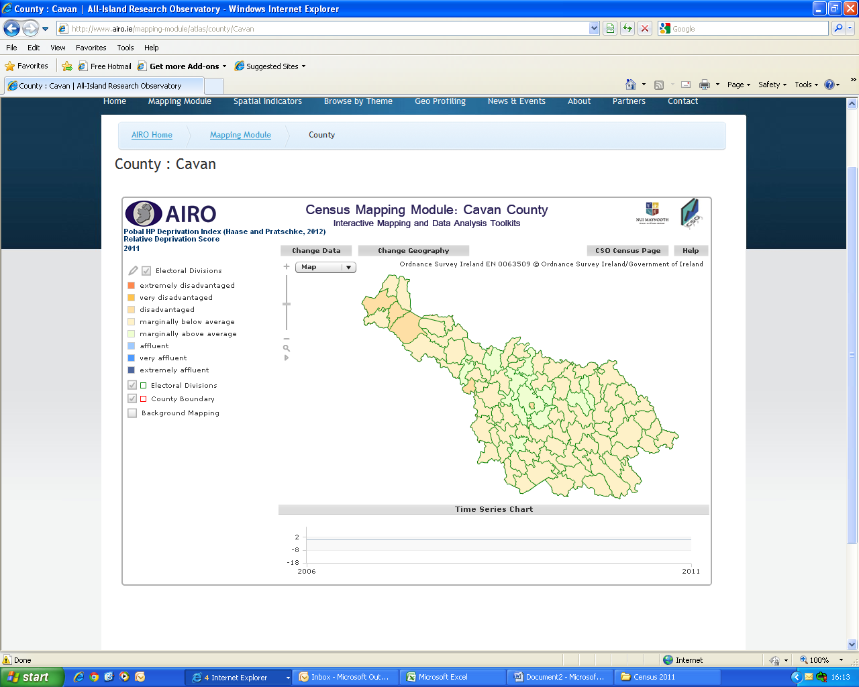

**Map B - Relative Deprivation Score 2006**

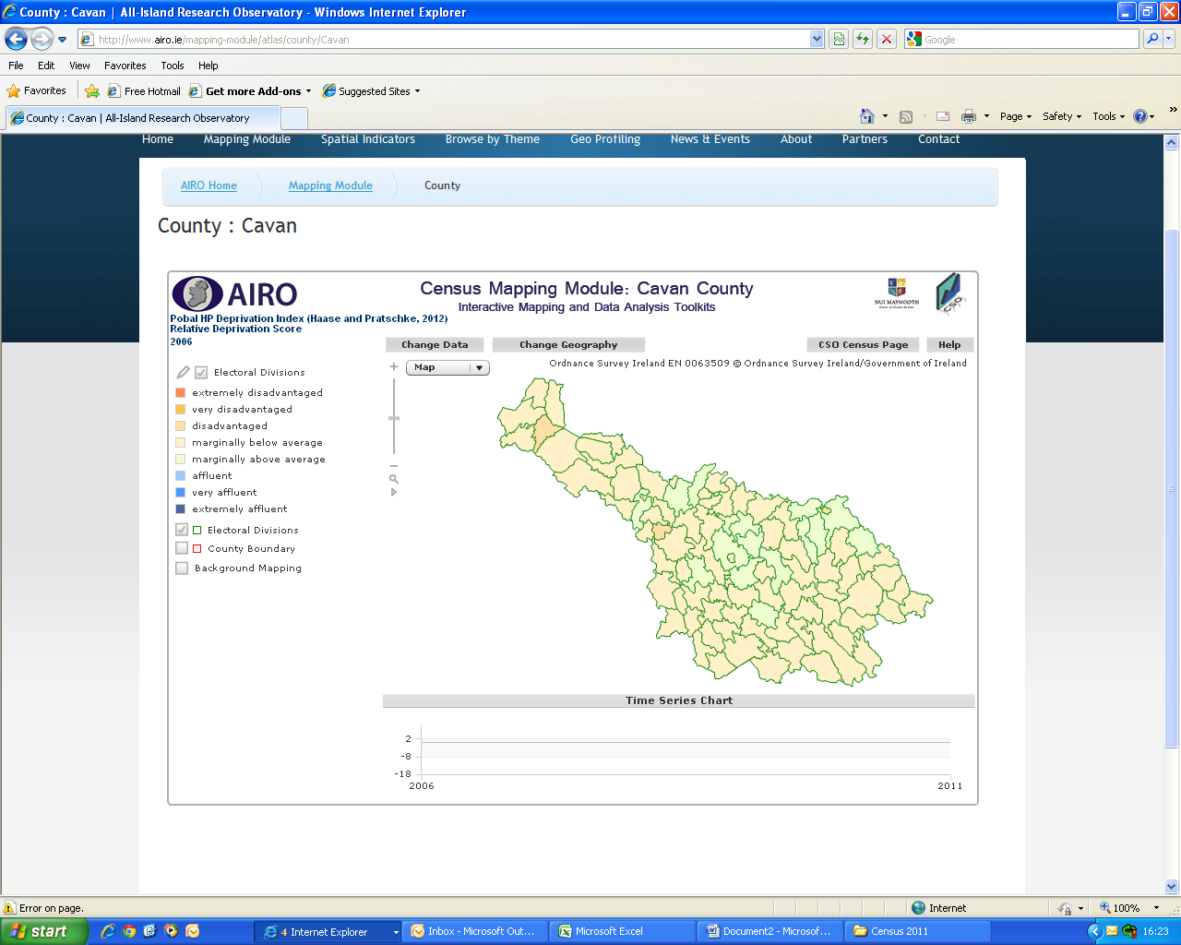

Source: All Island Research Observatory (AIRO) Maynooth

The deprivation index shows that of the 89 EDs in County Cavan in 2011, 72 (80% of EDs) are marginally below average while 12 are marginally above average and 5 EDs are in the disadvantaged range.

At a local level, the most disadvantaged EDs are Drumakeever/Derrynananta

(-16.8), Derrylahan (-12.8), Cavan Urban (-11.8), Killinagh/Teebane (-11.7) and Doogary (-10.2). These five EDs fall into the ‘disadvantaged’ category. All other EDs are, at the most, marginally below the national average.

The most affluent EDs are Butler’s Bridge (7.7), Tullyvin West (7.0) Cavan Rural (3.5), Lissanover (2.) and Carrafin (1.3). All of these are marginally above average, but no ED in County Cavan falls into the affluent category. (Haase and Engling)

**Disadvantage at the Small Areas Level**

The focus of the Social Inclusion Community Activation Programme (SICAP) is on areas defined as Disadvantaged, Very Disadvantaged or Extremely Disadvantaged. An analysis of the Small Area Population Statistics (SAPS) and Pobal has identified those small areas which register in any of these three categories in County Cavan. There are no small areas in the county registering as Extremely Disadvantaged, some three electoral divisions all in urban areas have “small areas” within them which are classified as Very Disadvantaged. The areas classified as Very Disadvantaged are located in Cavan Town, Bailieborough where the areas are quite extensive and Cootehill where there is a lesser concentration. There are, in all, twenty one electoral divisions containing small areas classified as ‘Disadvantaged’ or ‘Very Disadvantaged’.

Local Government reform has lead to the creation of three new municipalities in County Cavan. These three are largely equal in terms of population size and are denominated as ‘Cavan-Belturbet’ covering Cavan Town and the north west, ‘Bailieborough-Cootehill’ covering the east and ‘Ballyjamesduff’ covering the southern part of the county. Some 43.61% of the people living in areas of disadvantage are in the Cavan-Belturbet Municipality area with 19.08% in Cavan Town alone with the towns of Belturbet, Ballyconnell and Killeshandra making up a further 16.90% and the remaining 7.63% being in the rural areas of West Cavan.

A total of 32.10% of those living in disadvantaged areas are located in the Bailieborough-Cootehill Municipality area with 10.23% in Bailieborough, 8.66% in Cootehill and 8.21% in Kingscourt. The town of Shercock and the rural area of Drumcarn in the north account for the remaining 5%.

The Ballyjamesduff Municipality area accounts for 24.28% of those living in areas classified as disadvantaged in the county. The town of Ballyjamesduff accounts for 8.92%, Mullagh for 3.65% and Virginia for 3.05%. The towns of Kilnaleck and Ballinagh account for 4.65% between them and the rural areas of Denn and Kill contain the remaining 4.01%.

**Table x: Number and Percentage of people in Disadvantage by Municipality.**

|  |  |  |
| --- | --- | --- |
| **MUNICIPALITY OF CAVAN-BELTURBET** | | |
| **Area** | **No of People in Disadvantaged /Very Disadvantaged Areas.** | **% of all People living in Disadvantaged/ Very Disadvantaged areas in County** |
| Ballyconnell | 363 | 3.99 |
| Belturbet | 862 | 9.47 |
| Cavan Town | 1,736 | 19.08 |
| Corlough | 146 | 1.60 |
| Derrylahan | 96 | 1.05 |
| Doogarry | 147 | 1.61 |
| Dunmakeever/  Derrynanta | 152 | 1.67 |
| Killeshandra | 313 | 3.44 |
| Killinagh/  Teebane | 154 | 1.70 |
| **Totals** | **3,969** | **43.61** |

|  |  |  |
| --- | --- | --- |
| **MUNICIPALITY OF BAILIEBOROUGH-COOTEHILL** | | |
| **Area** | **No of People in Disadvantaged /Very Disadvantaged Areas.** | **% of all People living in Disadvantaged/ Very Disadvantaged areas in County.** |
| Bailieborough | 931 | 10.23 |
| Cootehill | 780 | 8.66 |
| Drumcarn | 216 | 2.37 |
| Kingscourt | 747 | 8.21 |
| Shercock | 239 | 2.63 |
| **Totals** | **2,921** | **32.10** |

|  |  |  |
| --- | --- | --- |
| **MUNICIPALITY OF BALLYJAMESDUFF** | | |
| **Area** | **No of People in Disadvantaged /Very Disadvantaged Areas.** | **% of all People living in Disadvantaged/ Very Disadvantaged areas in County** |
| Ballinagh | 201 | 2.21 |
| Ballyjamesduff | 811 | 8.92 |
| Denn | 210 | 2.31 |
| Kill | 153 | 1.70 |
| Kilnaleck | 222 | 2.44 |
| Mullagh | 332 | 3.65 |
| Virginia | 277 | 3.05 |
| **Totals** | **2,206** | **24.28** |

Source CSO Census 2011 and Pobal Deprivation Index.

The number of persons living in small areas classified as disadvantaged or very disadvantaged is 9,096 or 12.43% of the population of the county based on census 2011 and the Pobal index.

**5.2 Earnings & Disposable Income**

Levels of disposable income in Cavan are below the national average, however all regions except Dublin were below the national average. In 2010, disposable income per person in Cavan was €17,300 compared to €21,515 for Dublin and a national average of €19,318. Cavan levels had fallen 3 percentage points between 2005 and 2010 (CSO regional quality of life).

**5.3 Ethnic Minorities (including Travellers)**

The 2011 Census of Population records the ethnic diversity of Cavan County, see Table xx for a breakdown of this.

|  |  |
| --- | --- |
| **Population Usually Resident and Present in the State in County Cavan by Ethnic or Cultural Background** | |
| White Irish | 62,033 |
| White Irish Traveller | 452 |
| Any other White background | 6,833 |
| Black or Black Irish – African | 645 |
| Black or Black Irish - any other Black background | 73 |
| Asian or Asian Irish – Chinese | 119 |
| Asian or Asian Irish - any other Asian background | 606 |
| Other including mixed background | 554 |
| Not stated | 1,217 |
| All ethnic or cultural backgrounds | 72,532 |

Source: Census 2011

33 Congolese Refugees came to County Cavan under the Department of Justice’s Re-settlement Programme in 2014.

According to the 2011 census twelve per cent of the county’s population (8,830 people) are categorised as being of ‘other’ (ie. non-Irish) ethnic or cultural background.

It also recorded County Cavan as having the biggest percentage increase in its Traveller population (where Traveller numbers rose by 114 per cent), with 453 Travellers recorded to be living within the County. However, Cavan has a low number of Travellers in its population compared to other counties. Galway county had the highest number of Irish Travellers of all the administrative counties, with 2,476 persons, followed by South Dublin with 2,216.

Very few Travellers now live in caravans and mobile homes (12% nationally), this has dropped from 25% in 2006. Cavan had the highest proportion of Travellers living in permanent housing (97% of Travellers).

However compared to other Counties Cavan has quite a low number of Travellers within its population.

**5.4 Disability**

11.9 per cent of County Cavan’s population have been classified as having a disability according to the 2011 census, up from 8.5 per cent in 2006. In terms of numbers with a disability this is a percentage change of 60.3 per cent. We fall just below the State which stands at 13 per cent of the population in 2011. The electoral divisions with the highest population of people with a disability would include Cavan Rural (867), Cavan Urban (710), Bailieborough (494) and Virginia (462).

**Figure 14: Persons with a disability. County Cavan, 2011.**

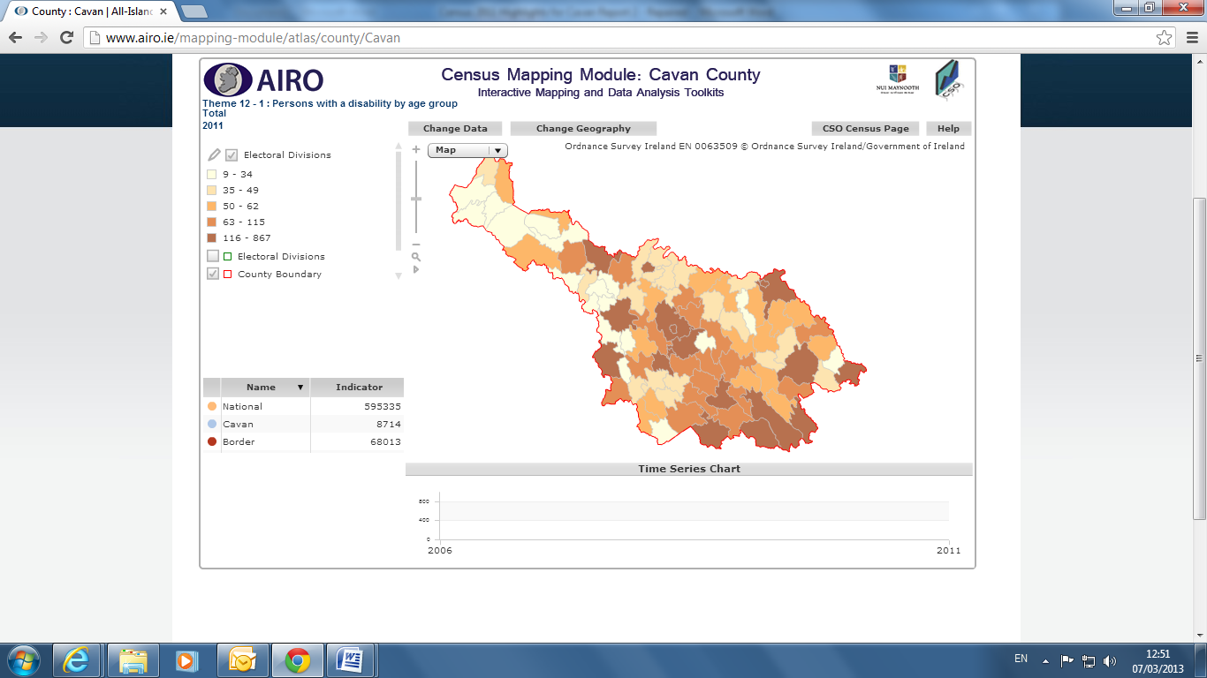

Source: All Island Research Observatory (AIRO) Maynooth

Table x shows that the majority of those with a disability within the County are Males at 51.4 per cent.

**Table x: Persons with a disability by gender. County Cavan. 2011.**

|  |  |  |
| --- | --- | --- |
| **Disability by Gender** | **Number** | **Percentage** |
| Males | 4,480 | 51.4% |
| Females | 4,234 | 48.6% |
| **Total** | **8,714** |  |

The total population by type of disability is shown in Table x for both the County and State. As can be seen ‘Other disability, including chronic illness’ is the highest proportion for both County Cavan (16%) and the State (17%), followed closely by the category of ‘A condition that substantially limits one or more basic physical activities’.

**Table x: Total population by type of disability. County Cavan. 2011.**

|  |  |  |  |  |
| --- | --- | --- | --- | --- |
| **Disability Type** | **Cavan** | **%** | **State** | **%** |
| Blindness or a serious vision impairment | 729 | 3 | 51,718 | 3 |
| Deafness or a serious hearing impairment | 1,396 | 6 | 92,060 | 6 |
| A condition that substantially limits one or more basic physical activities | 3,840 | 15 | 244,739 | 15 |
| An intellectual disability | 828 | 3 | 57,709 | 4 |
| Difficulty in learning, remembering or concentrating | 2,012 | 8 | 137,070 | 7 |
| Psychological or emotional condition | 1,168 | 5 | 96,004 | 6 |
| Other disability, including chronic illness | 3,921 | 16 | 274,762 | 17 |
| Difficulty in dressing, bathing or getting around inside the home | 2,146 | 9 | 125,450 | 8 |
| Difficulty in going outside home alone | 2,677 | 11 | 165,681 | 10 |
| Difficulty in working or attending school/college | 2,961 | 12 | 194,398 | 12 |
| Difficulty in participating in other activities | 3,228 | 13 | 207,455 | 13 |

As can be seen from Figure xx the largest proportion of people with a disability within the county fall into the age category of 65+ years (37.43%). Overall it can be seen that the rates of disability increased with age group, the exception being those within the age category of 15-24, which has the lowest disability rate. This was the same pattern for both 2006 and 2011.

The biggest change between 2011 and 2006 was within the age category of 65+ which saw a drop in percentage of -4.15 between 2006 and 2011.

**Figure xx: Percentage of people with a disability by age group. County Cavan. 2006 & 2011**

**5.5 Carers**

In the census carers are defined as people who provide regular unpaid personal help for a friend or family member with a long term illness health problem or disability

There were 2,553 carers recorded in County Cavan in the 2006 census. In 2011 this number increased by 440, bringing the total number of carers to 2,933 standing at 4 per cent of the county’s population. Females lead as being the majority of carers (57%). As Table x shows the largest proportion of carers dedicated 1 to14 hours caring per week (1,166), followed by 43 or more hours a week (630).

2.3 per cent of people aged 85 and over in Cavan are acting as carers.

**Table xx: Carers by gender and number of unpaid hours per week. County Cavan. 2011.**

|  |  |  |  |
| --- | --- | --- | --- |
| **Number of hours** | **Males** | **Females** | **Total** |
| 1-14 | 511 | 655 | 1,166 |
| 15-28 | 198 | 300 | 498 |
| 29-42 | 107 | 119 | 226 |
| 43+ | 230 | 400 | 630 |
| Not stated | 190 | 223 | 413 |
| **Total** | **1,236** | **1,697** | **2,933** |

**5.6 Health**

A new question on general health was introduced for the first time in census 2011 and asked respondents to select one of five categories ranging from very good to very bad. Self-perceived health provides a well validated and widely used measure of actual health, despite its subjective nature.

Table xx shows that overall the vast majority of County Cavan’s population (96.76 %) believe their general health was either very good, good or fair on census night. Only 0.20 per cent of people in Cavan said their health was very bad, and 1.09 per cent said it was bad.

Nationally 5.4% of people in unskilled social classes said their health was very bad. It is known that health risks are higher for people in poverty.

**Table xx: Population by general health. County Cavan and State, 2011.**

|  |  |  |  |  |
| --- | --- | --- | --- | --- |
| **General Health** | **State** | | **Cavan** | |
|  | **Number** | **%** | **Number** | **%** |
| General health - All | 458,8252 |  | 73,183 |  |
| General health - Very good | 276,7681 | 60.32 | 45,084 | 61.60 |
| General health - Good | 128,2956 | 27.96 | 19,681 | 26.89 |
| General health - Fair | 368,131 | 8.02 | 6,029 | 8.24 |
| General health - Bad | 57,243 | 1.25 | 798 | 1.09 |
| General health - Very Bad | 12,418 | 0.27 | 145 | 0.20 |
| Not stated | 99,823 | 2.18 | 1,446 | 1.98 |

**Poverty and Social Inclusion: Key Statistics**

* Between 2006 and 2011 the absolute deprivation score in Cavan dropped from -2.8 to -11.0, representing a drop 8.2 compared to a nationwide drop of 6.5.
* Cavan is the eight most disadvantaged local authority area in Ireland.
* There are no small areas in the county registering as ‘Extremely Disadvantaged’.
* There are 21 electoral divisions in the county containing “small areas” classified as ‘Disadvantaged’ or ‘Very Disadvantaged’. The total population of these areas is 9,096 persons.
* The most disadvantaged electoral divisions within the County are Drumakeever/Derrynananta (-16.8), Derrylahan (-12.8), Cavan Urban (-11.8), Killinagh/Teebane (-11.7) and Doogary (-10.2). These five electoral divisions fall into the ‘Disadvantaged’ category. All other electoral divisions are, at the most, marginally below the national average.
* Levels of disposable income in Cavan are below the national level - in 2010 disposable income per person was €17,300 compared to a national average of €21,515
* Twelve per cent of the county’s population (8,830) are categorised as being non-Irish.
* Cavan has the highest percentage increase in its traveller population with 453 Travellers living in the County.
* 11.9 per cent of County Cavan’s population have been classified as having a disability according to 2011 census, this compares with the State average of 13 per cent
* For 2011 the total number of carers in Cavan stood at 2933, this representing 4 per cent of the County’s population
* 2.3 per cent of people aged 85 and over in Cavan are acting as carers.

**Chapter 6: Infrastructure & Connectivity**

**6.1 Transport**

**Road** :Cavan is served by three National Arterial Routes, the M3, N55 and N16, and is a gateway to and from Dublin, the Midlands, the North, and North West.

Cavan town is also a pivotal location on the East-West route from Dundalk to Sligo and just in excess of one hour from the M50 (Dublin) and approximately 1.5 hours from Belfast.

**Public Transport:** Bus Eireann operates services to and from Dublin on an hourly basis, with services also to Enniskillen, Dundalk, Galway and Belfast on a daily basis. Several private operators also provide services to Dublin, Athlone, Dundalk and other major centres.

**Rural Transport**: The Rural Transport Programme (RTP)provides services to people whose travel needs are not met by existing bus or train services. The Programme aims to enhance and sustain nationwide accessibility, through community based participation, particularly for those at risk of social exclusion. It plays a major role in combating rural isolation and acts as a catalyst in creating models of partnership, at all levels, where key sectors actively engage in transport provision, to ensure equality of access for all. Services funded under the Programme complement, rather than compete with, existing public transport services provided by CIE Companies or by private transport operators. Since April 2012, the RTP is being managed by the National Transport Authority. Major restructuring has resulted in the establishment of 18 Transport Co Ordination units ( previously 35 in number). As part of this restructuring process Cavan and Monaghan have been merged in to the Cavan Monaghan Transport Co Ordination Unit, which will be responsible for co-ordinating rural transport for both counties.

**Airports:** Dublin International Airport, Belfast International, and Belfast City Airports offer an international network of passenger and freight services within 90 minutes of Cavan town. Ireland West Airport also provides a viable option, particularly for the West Cavan Area.

**Shipping:** The main ports of Drogheda, Greenore, Warrenpoint, Dublin, Larne and Belfast are all within easy reach of Cavan and provide all major services required by industry.

**Car ownership:** 86 per cent of households have at least one car and only 14 per cent have no motor car at all within County Cavan. Cavan households were more likely to have a car (86.2%) than the average for the State (82.4%)

**Figure X: Number of households with cars. County Cavan, 2011.**

**Means of travel**

As Figure x shows the majority of people (aged 5 years and over) within the county make their way to either school, college or work by car (41%), or being a car passenger (20%).

**Figure x: Means of travel to work, school or college. County Cavan, 2011.**

**Travel time**

Most people within the County make their journey to either work, college or school in under 15 minutes (40.1%). The average journey time for the State is 26.6 minutes so the majority of people within County Cavan would fall below this.

**Table 9: Journey time to work, school or college. County Cavan and State, 2011.**

|  |  |  |  |  |
| --- | --- | --- | --- | --- |
| **Journey Time** | **County Cavan (No.)** | **County Cavan (%)** | **State (No.)** | **State (%)** |
| Under 15 minutes | 16,638 | 40.1 | 427,993 | 25.2 |
| 1/4 hour - under 1/2 hour | 10,853 | 26.2 | 520,128 | 30.7 |
| 1/2 hour - under 3/4 hour | 5,878 | 14.1 | 352,362 | 21.0 |
| 3/4 hour - under 1 hour | 1,629 | 3.9 | 123,298 | 7.2 |
| 1 hour - under 1 1/2 hours | 1,980 | 4.7 | 112,701 | 6.6 |
| 1 1/2 hours and over | 1,367 | 3.3 | 39,764 | 2.3 |
| Not stated | 3,074 | 7.4 | 118,828 | 7.0 |
| Total | 41,419 |  | 1,695,074 |  |

**6.2 Telecommunication / Broadband:**

Good quality high speed broadband is essential to furthering the social and economic development of the County. Metropolitian Area Networks have been installed in larger towns across the County including Cavan Town, Cootehill, Kingscourt and Bailieborough. E- Fibre is being rolled out across the County by Eircom and a new joint venture between Vodafone and the ESB and has also included Cavan Town in the first phase of their new national fibre broadband network

As Table x represents 17,270 households in County Cavan have a personal computer. This is quite a significant jump from 2006 when only 10,796 of the population owned one. There has also been a huge improvement in the availability of access to broadband across the county with 55.4 percent of households having access to broadband in 2011 compared with only 9 per cent of households having access in 2006.

The proportion of homes using slower types of internet connection decreased accordingly from 29.9 per cent in 2006 to 9.5 per cent in 2011 while those with no internet connection fell from 48.1 per cent to 32.7 per cent.

**Table 11: Private households classified by personal computer ownership and access to the internet. Number & Percentages. County Cavan, 2011.**

|  |  |  |  |  |  |  |  |  |
| --- | --- | --- | --- | --- | --- | --- | --- | --- |
| **County** | **Total** | **Personal Computer Ownership** | | | **Access to the Internet** | | | |
| **Yes** | **No** | **Not Stated** | **Broadband**  **Connection** | **Other connection** | **No connection** | **Not Stated** |
| **County Cavan (No.)** | 25,720 | 17,270 | 7,905 | 545 | 14,250 | 2,445 | 8,426 | 599 |
| **County Cavan %** |  | 67.1 | 30.7 | 2.1 | 55.4 | 9.5 | 32.7 | 2.3 |

Nationally broadband usage has increased from 21.1 per cent in 2006 to 65.3 per cent in 2011.

**Infrastructure and Connectivity: Key Statistics**

* Cavan is served by three National Arterial Routes, the M3, N55 and N16, and is a gateway to and from Dublin, the Midlands, the North, and North West.
* The Rural Transport Programme (RTP)provides services to people whose travel needs are not met by existing bus or train services.
* 86 per cent of households have at least one car and only 14 per cent have no motor car at all within County Cavan.
* Most people within the County make their journey to either work, college or school in under 15 minutes (40.1%).
* County. Metropolitian Area Networks have been installed in larger towns across the County including Cavan Town, Cootehill, Kingscourt and Bailieborough.
* 17,270 households in County Cavan have a personal computer.
* 55.4 percent of households having access to broadband in 2011.

**Appendix 1**

Table XX Key Companies and Business Sectors in the County Cavan, 2013

| **Company** | **Business Sector** |
| --- | --- |
| **ABCON** | Manufacture industrial tools and abrasives |
| **Airpacks** | Manufacture expanded polystyrene insulation |
| **ATA Group** | Manufacture of abrasive products for heavy industry, utilities, etc. |
| **Ballytherm** | Manufacture insulation |
| **Boxmore Plastics (Chesapeake)** | Manufacture plastic bottles and containers. |
| **Carton Brothers / Manor Farm Chickens** | Producers of chicken products |
| **CG Power Systems** (Compton Greaves, formerly Pauwells Trafo) | Manufacture transformers for utility companies. |
| **Flair International** | Manufacture shower enclosures |
| **Foamalite** | Manufacture of PVC foam sheeting products |
| **FSW Coatings (Fleetwood)** | Paint Manufacture |
| **Gem Plastics** | Manufacture of plastic barrels and containers |
| **Glanbia** | Producer of milk and milk products |
| **Global Indemnity Services** | Call centre for property and casualty insurance. IT Operations, |
| **Gypsum Industries** | Manufacture of plaster products. |
| **Kingspan** | Manufacturing of insulation, building products and environmental equipment |
| **Lakeland Dairies** | Production of milk products and other agri-related services – international scale |
| **Liberty Insurance** | Call Centre – insurance sales |
| **Liffey Meats** | Processing of cattle meat products |
| **McCarren Meats** | Processing of pork products – export scale |
| **O’Reilly Precast Concrete Products** | Precast Concrete Products |
| **Obelisk Group** | Provide infrastructure to the telecoms industry – international markets |
| **P&S Civil Works** | Construction of wind farms, roads, housing, etc |
| **PQE Technology** | Precision Engineering Components |
| **Quinn Cement** | Manufacture of cement |
| **Quinn Packaging Ireland** | Manufacturers of food packaging products |
| **Quinn Therm / Lite Pac** | Manufacturer of building insulation |
| **Terra Ltd** | Manufacture of liqueurs and spirits drinks, bottling |
| **Univet** | Manufacture of veterinary medicines |
| **Virginia International Logistics** | International transport & logistics firm |
| **Wellman International** | Manufacture polyester fiber, much from recycled plastic bottles. |

Source: Irish Central Border Area Network (ICBAN) - Data Profile of the Irish Central Border Region. January 2014

Cavan and Monaghan Educational Training Board offer the following Training Programmes within the region:

