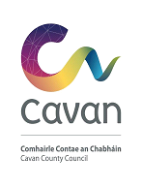
TVRS - Streetscape Enhancement Scheme 2021
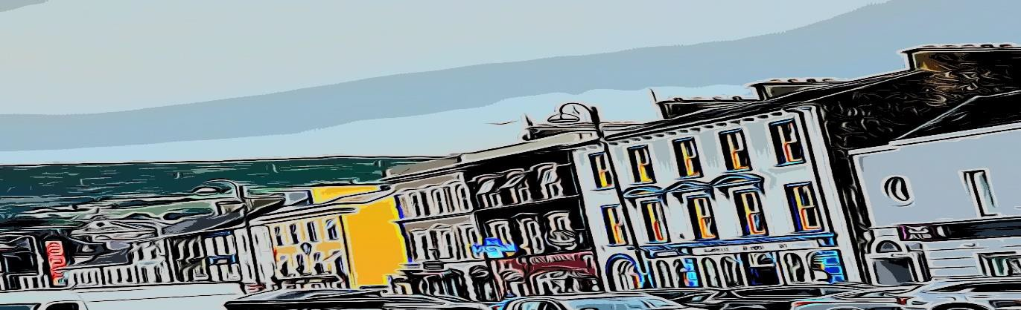
Application Form

Please complete this application form and return it to:
Cavan County Council – the designated contact(s) are Diane McEnerney or Bernie O’Rourke; email: dmcenerney@cavancoco.ie or borourke@cavancoco.ie
Closing date for receipt of completed applications: 4pm on Thursday 2nd September 2021
Please read the terms and conditions attached to this scheme prior to completing the form.
WORKS MUST NOT COMMENCE PRIOR TO RECEIPT BY CAVAN COUNTY COUNCIL OF
THE GRANT APPLICATION FORM AND WRITTEN APPROVAL ISSUED FROM CAVAN COUNTY COUNCIL

Applicant Information
Applicant Name:

Applicant Address:

Property Eircode:
Business Name:
(if a business is currently
operating from the premises)

Business Address (include Eircode):
(if a business is currently
operating from the premises)

Business Type:
(if relevant)

Contact No (Landline) | Contact No (Mobile)
Shopfront (Tick if applicable) | Residence (Tick if applicable)
E-Mail Address:
Applicant’s Interest in Property: (owner or tenant)
If a tenant, please state the number of years remaining on the lease:
Also attach a letter of consent from the owner for the improvement works.

Proposed Works:
Please include supplementary information with exact details of works proposed including a copy of relevant plans, designs and specifications for proposed works.
Two quotations are required (Three if the value is greater than €5,000) See section 2.7 terms & conditions.
All applications must include colour photographs of the existing property and colour photographs must subsequently be submitted of completed works before funds can be drawn down.
Please tick relevant proposed works:

- Green enhancement of entrances/ terraces with planting (max €500)

- a. Painting of building/shopfront in carefully selected colours which will complement the host building and streetscape (max grant combined elements 2a & 2b €1,500)

b. Mural (design agreed in advance with Cavan County Council)

- Decluttering and repair of shopfronts. (Decluttering can include such works as removing unnecessary signs, flagpoles, wiring etc.) (max grant €2,000)

- a. Careful illumination and lighting of architectural features of buildings.

b. Improvements to shopfront window displays and staging.
c. Replacement of signage with traditional wooden fascia with wooden/hand painted lettering OR contemporary design

d. Canopies/Awnings complementary to the materials of the shopfront and building (including street furniture).

e. Replacement of existing shopfront with traditional painted wooden shopfront OR contemporary design

(Max grant for element 4 is €4,000)

Maximum grant payable per building is €8,000.
Note: Please include exact details of works proposed including a copy of any relevant plans, designs and specifications for proposed works.

Is planning permission required for any of the proposed works: Yes No

Where planning consent is not in place and a proposal involves a material alteration to the structure, planning permission will be required at payment stage. Please note that it is the applicant’s responsibility to ensure the requirements for planning permission have been met. Such requirements are not dealt with through the application process for this Scheme.
Applicants are advised to contact Cavan County Council in advance of making an application for funding under this scheme to discuss individual proposals which involve alterations to or replacement of existing shopfronts. Any such alterations must be consistent with the guidance laid out in the Draft County Development Plan. Guidance will be provided by Cavan County Council upon request.
Is this a single application or part of a group of applications (definition of groups is 3 or more adjacent premises) if part of a group of applications, please provide details or other premises in the group; |  | Single  Group
Total Value of Proposed Works: |  | €:
Value of Grant Assistance Sought:  Please refer to terms & conditions Section 1.5 for grant rates and Appendix 1 for eligible works and maximum grant per works element: |  | €:
Proposed Start Date of Works:
Proposed Completion Date of Works:
Please note that all works must be completed by 5th November 2021 to avail of funding

DECLARATION

I hereby confirm that I have read and understood this document and Terms and Conditions of the Scheme. All information given on this form and any supporting material is correct to the best of my knowledge.
I agree to the Cavan County Council making any necessary enquiries for assessment of this project.
I note that Cavan County Council reserves the right to publish photographs of improved premises in promotional material.

Signature __________________________________________________

Position __________________________________________________

Date __________________________________________________

Checklist:

• Fully completed application form (all answers filled in)

• Letter of Consent from Property Owner (if REQUIRED)

• Copy of relevant detail for proposed works. Note that planning permission may be

required for some works and it is the applicant’s responsibility to ensure the

requirements for planning permission have been met. Such requirements will not

be dealt with through the application process for this scheme.

• Colour photographs of the existing property.

• quotations required for PROPOSED works.

CAVAN COUNTY Council reserves the right to publish photographs of improved shopfronts and building facades in promotional material associated with the scheme and its purpose.

The Scheme may be the subject of review and amendment at any time by CAVAN COUNTY Council.

THIS SECTION OF FORM IS FOR OFFICE USE ONLY
Office Use Only:  Town in which premises is located: | Date Application Received:
Application Complete:  Yes  No | Photograph Included:  Yes  No
F/I Requested:  Yes  No | F/I Received:  Yes  No
Decision to Grant Assistance:
Yes

No

