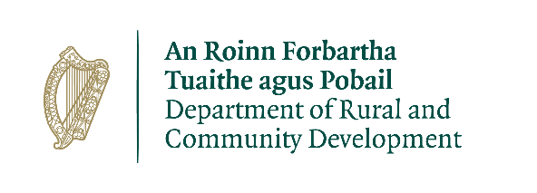

***Project Application for Connected Hubs Call***

**Form 1: Single Hub Applications Only**

Application Reference Number (DRCD to Complete):

This form should be completed and returned by e-mail to [rdi@drcd.gov.ie](mailto:rdiu@drcd.gov.ie) by close of business on **17 June 2021.**

All queries should be addressed to: [rdi@drcd.gov.ie](mailto:rdiu@drcd.gov.ie)

Subject line should read: “Connected Hubs Query”

If required (see section 4) please include a short an abbreviated business plan and financial projections.

**Please note that all fields are mandatory**

**ADMINISTRATION:**

|  |  |
| --- | --- |
| **Hub Name:** |  |
| **Public Body:** | Yes/No (delete as appropriate) |
| **Local Authority Area:** |  |
| **Project Townland:** |  |
| **Postal Address of project:** |  |
| **Eircode:** |  |
| **Amount of Funding Requested:** |  |
| **Lead applicant contact Name:** |  |
| **Contact email address:** |  |
| **Contact telephone number:** |  |

**PROJECT DETAILS:**

|  |  |
| --- | --- |
| 1. **Please provide a brief description of project (Max 300 words)** | |
|  | |
| 1. **Project Proposal (Max 1000 words)** | |
|  | |
| **3. Who will implement the project?** | |
|  | |
| 1. **Please provide a brief explanation as to how this project will assist local businesses/communities to adapt to the specific challenges posed by COVID-19 (e.g. social distancing) AND/OR increase footfall/economic activity in the short-term (Max 400 words).**   ***Only complete this question if applying for measures to address Covid-19.*** | |
|  | |
| **5. When will work on the project commence and how long will the proposed work take to complete?** | |
| * **Proposed commencement date:** |  |
| * **Project duration:** |  |
| * **Proposed completion date:** |  |

**FINANCIAL DETAILS:**

|  |  |
| --- | --- |
| **VAT No.:** |  |
| **Tax Registration Number:** |  |
| **Tax Clearance Access Number:** |  |
| **CRA Registration Number (if applicable):** |  |

**PROJECT COSTINGS:**

Please provide a detailed breakdown of all elements of the proposed works:

|  |  |
| --- | --- |
| **(Itemise various elements)** | € |
|  | € |
|  | € |
|  | € |
|  | € |
| **TOTAL PROJECT COST:** | € |
| **Amount of grant aid sought: \*** |  |
| **Match funding to be provided: \*** |  |
| **Amount of cash contribution:**  (Minimum of 5% of total cost) |  |
| **Cash contribution to be supplied by:** |  |
| **Amount of in-kind contribution: \*** |  |
| **Form of in-kind contribution:** |  |
| **How will the in-kind contribution be delivered:** |  |

* See Section 6: Grant Funding for further details regarding in-kind contribution levels from Public Owned and all other hubs.

**DECLARATION**

I request that assistance be given in support of the project as outlined and certify that, if made, the grant will be solely for the purpose for which it is approved. I confirm that the particulars of this application are correct and that the funded body confirms:

* that match funding is in place and that evidence and source of the match funding is held;
* that necessary permissions are in place or in train;
* that evidence of ownership/lease (if applicable) is in line with Scheme Outline;
* that resources are available to provide for ongoing maintenance of the project, if applicable;
* that the organisation commits to a three-year membership of the National Hub Network.

Proof of the above is not required at the time of application but must be held on file by the funded body and must be available to the Department or its agents on request.

|  |  |
| --- | --- |
| **Signed:**  **(Lead applicant)** |  |
| **Title:** |  |
| **Date:** |  |