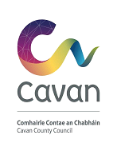
Cavan County Council

Data Protection – Access Request
(Data Protection Act 2018 & General Data Protection Regulation)
In relation to my Personal Data I want to – (please select from the following options)
Confirm data is held and/or obtain access
Correct/update my personal data
Object to processing of personal data
Have my personal data deleted
Restrict how my personal data is used

Name: Mr/Mrs/Ms
Address:
Contact Number:
Email Address:

You do not have to provide all contact details above but providing details, such as email and phone makes it easier to communicate.

Cavan County Council

To assist Cavan County Council in assigning your request to the correct department as soon as possible please briefly describe the detail of your request and for example, where relevant, name a specific service or department.
Details of your application:

Checklist: Have you?
- Completed all sections above
- Provided proof of your identity & proof of address
Please return your completed application to:
Postal Address: Data Protection Officer
Cavan County Council
Courthouse
Farnham Street
Co. Cavan
H12 R6V2
dpo@cavancoco.ie

