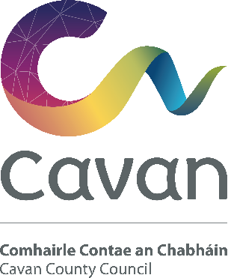

Cavan County Council

Smoke Alarm Scheme for Older People and People with Disabilities

Information Leaflet and Application Form
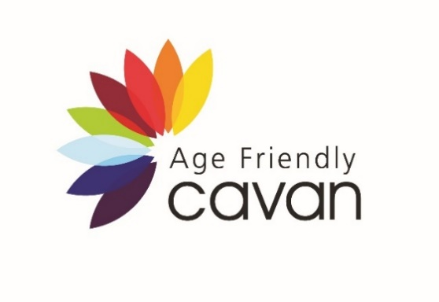
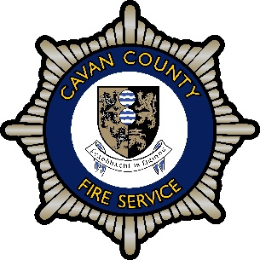

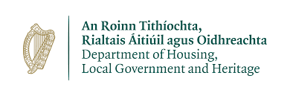

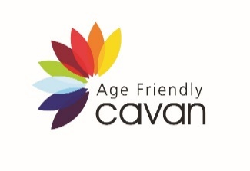
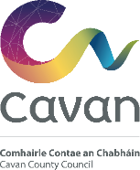
Smoke Alarm Scheme

Cavan County Council is making a number of smoke alarms available to older people and people with disabilities in County
Cavan. This initiative is funded by the Department of Housing, Local Government and Heritage.

We are now inviting applications from older people and people with disabilities who are living in County Cavan who are in need of a Smoke Alarm. Applications will be considered on a first come, first served basis with priority given to those aged over 80, people living alone and people with disabilities.

Each set of two alarms costs approximately €30 but will be provided free of charge. Both alarms are fitted with a 10-year long-life battery and do not require connection to mains electricity.

Cavan County Council

Smoke Alarm Scheme for
Older People and People with Disability

Application Form 2024

Name of Applicant

Telephone Number

Address (Including Eircode)

Please indicate with a ✓ your source of income:
Social Welfare □ Paid employment □
Private Pension □ Other income □ ________________

Please tick the boxes that best describe you:  Older person  Aged 55 - 79 ............................................................... | □
Aged 80+ ...............................................................  Do you live alone? ..................................................... | □  □
Person with disability  (please state nature of condition) ________________________ | □
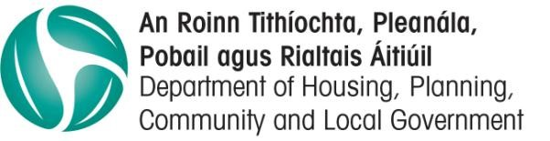

What type of house do you live in?
Owner occupied □ Private rented □
Local authority □ Other □ ________________

What area do you live in?
Rural area □ Village □ Urban area □

Is your house?
A bungalow □ Two-storey □
Semi-detached □ Detached □ Terraced □

Signed:

Date:

Please return your completed form to:
Cavan Age Friendly, Community & Enterprise Department, Cavan County Council, Farnham Centre, Farnham Street, Cavan.
or Email to agefriendly@cavancoco.ie

