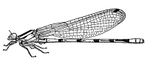

Whitehill Edgeworthstown Co. Longford

Whitehill Environmental
 (087) 4127248 / (043) 6672775
 noreen.mcloughlin@gmail.com

Noreen McLoughlin, MSc
Environmental Consultant

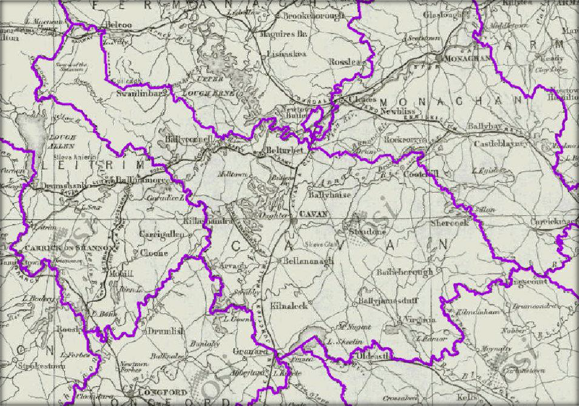

STATEMENT OF SCREENING FOR APPROPRIATE ASSESSMENT OF THE CAVAN LOCAL ECONOMIC AND COMMUNITY PLAN

IN LIN E W ITH TH E RE QU IR E ME N TS OF AR T IC LE 6 ( 3 ) OF TH E
EU HA B ITA TS DIR E C T IV E

Cavan County Council

December 2015

i

All Maps and Aerial Photography used in this report are reproduced under OSI Licence No. EN 0079014

AP P R OP R I AT E AS S E S S M E N T ( S T AG E I ) O F TH E CO UN T Y CAV AN L O C AL E C O N OM I C AN D COM M U NI T Y P L AN

TA B L E OF CON T E N T S
- INTRODUCTION 3
- METHODOLOGY 7
- DESCRIPTION OF THE CAVAN LECP 10
- NATURA 2000 SITES IDENTIFIED 12
- SCREENING OF POTENTIAL EFFECTS 31 APPENDIX I: REFERENCES 34

IN T R OD U CT ION

  - 1 B A CK G R OU N D
The implementation of the Local Government Reform Act, 2014 provides a structure which places local government firmly at the heart of public services by making it the lead agency for local, economic and community development. This objective was originally proposed in the Action Programme for Effective Local Government, Putting People First (DECLG, 2012) which states that “local government will be the main vehicle of governance and public service at local level, leading economic, social and community development”.

The Local Economic and Community Plan (LECP) will provide a strategic framework guiding local economic and community development in County Cavan for the next six years. It is the central strategy that will set the agenda for statutory agencies, elected representatives, community and voluntary groups and business interests to work collaboratively over the life of the plan for the betterment of County Cavan.

The LECP is prepared in accordance with Section 44 of the Local Government Reform Act 2014 and consists of two elements: A local economic element (prepared and adapted by the local authority) and a community development element (prepared and adapted by the Local Community Development Committee (LCDC).

  - 2 P U R P O S E O F T H E R E P O R T
This is an Appropriate Assessment Screening Report of the Draft Cavan Local Economic and Community Plan. This screening report has been prepared in accordance with Article 6 (3) of the Habitats Directive. The purpose of this screening report is to determine the appropriateness of the plan, in the context of the conservation status of relevant sites within 15km of the plan area. It will determine whether or not the plan is likely to have significant affects on the integrity of Natura 2000 sites identifed.

  - 3 R E G U L A T OR Y CON T E X T
RELEVANT LEGALISATION
The Birds Directive (Council Directive 79/409/EEC) implies that particular protection is given to sites (Special Protection Areas) which support certain bird species listed in Annex I of the Directive and that surveys of development sites should consider the status of such species.

The EU Habitats Directive (92/43/EEC) gives protection to sites (Special Areas of Conservation) which support particular habitats and species listed in annexes to this

directive. Articles 6(3) and 6(4) of this Directive call for the undertaking of an Appropriate Assessment for plans and projects likely to have an effect on designated sites. This is explained in greater detail in the following section.

The Wildlife Act 1976 (and its amendment of 2000) provides protection to most wild birds and animals. Interference with such species can only occur under licence. Under the act it is an offence to “wilfully interfere with or destroy the breeding place or resting place of any protected wild animal”. The basic designation for wildlife is the Natural Heritage Area (NHA). This is an area considered important for the habitats present or which holds species of plants and animals whose habitat needs protection. Under the Wildlife Amendment Act (2000) NHAs are legally protected from damage. NHAs are not part of the Natura 2000 network and so the Appropriate Assessment process does not apply to them.

The Water Framework Directive (WFD) (2000/60/EC), which came into force in December 2000, establishes a framework for community action in the field of water policy. The WFD was transposed into Irish law by the European Communities (Water Policy) Regulations 2003 (S.I. 722 of 2003). The WFD rationalises and updates existing legislation and provides for water management on the basis of River Basin Districts (RBDs). RBDs are essentially administrative areas for coordinated water management and are comprised of multiple river basins (or catchments), with cross-border basins (i.e. those covering the territory of more than one Member State) assigned to an international RBD. The aim of the WFD is to ensure that waters achieve at least good status by 2015 and that status doesn’t deteriorate in any waters.

APPROPRIATE ASSESSMENT AND THE HABITATS DIRECTIVE
Directive 92/43/EEC on the Conservation of Natural Habitats and Wild Fauna and Flora – the ‘Habitats Directive’ - provides legal protection for habitats and species of European importance. Article 2 of the Directive requires the maintenance or restoration of habitats and species of European Community interest, at a favourable conservation status. Articles 3
- 9 provide the legislative means to protect habitats and species of Community interest through the establishment and conservation of an EU-wide network of sites known as Natura 2000. Natura 2000 sites are Special Areas of Conservation (SACs) designated under the Habitats Directive and Special Protection Areas (SPAs) designated under the Conservation of Wild Birds Directive (79/409/EEC).

Articles 6(3) and 6(4) of the Habitats Directive sets out the decision-making tests for plans or projects affecting Natura 2000 sites. Article 6(3) establishes the requirement for Appropriate Assessment:

“Any plan or project not directly connected with or necessary to the management of the site but likely to have a significant effect thereon, either individually or in combination with other plans or projects, shall be subject to appropriate assessment of its implications for the site in view of the site's conservation objectives. In the light of the conclusions of the assessment of the implications for the site and subject to the provisions of paragraph 4, the competent national authorities shall agree to the plan or project only after having ascertained that it will not adversely affect the integrity of the site concerned and, if appropriate, after having obtained the opinion of the general public.”

Article 6(4) deals with the steps that should be taken when it is determined, as a result of appropriate assessment, that a plan/project will adversely affect a European site. Issues dealing with alternative solutions, imperative reasons of overriding public interest and compensatory measures need to be addressed in this case.

Article 6(4) states:

“If, in spite of a negative assessment of the implications for the site and in the absence of alternative solutions, a plan or project must nevertheless be carried out for imperative reasons of overriding public interest, including those of a social or economic nature, the Member States shall take all compensatory measures necessary to ensure that the overall coherence of Natura 2000 is protected. It shall inform the Commission of the compensatory measures adopted.

Where the site concerned hosts a priority natural habitat type and/or a priority species, the only considerations which may be raised are those relating to human health or public safety, to beneficial consequences of primary importance for the environment or, further to an opinion from the Commission, to other imperative reasons of overriding public interest.”

THE APPROPRIATE ASSESSMENT PROCESS
The aim of Appropriate Assessment is to assess the implications of a proposal in respect of a site’s conservation objectives.

Appropriate Assessment is an assessment of the potential effects of a proposed plan - ‘in combination’ with other plans and projects - on one or more European sites. The ‘Appropriate Assessment’ itself is a statement which must be made by the competent authority which says whether the plan affects the integrity of a European site. The actual process of determining whether or not the plan will affect the site is also commonly referred to as ‘Appropriate Assessment’.

If adverse impacts on the site cannot be avoided, then mitigation measures should be applied during the Appropriate Assessment process to the point where no adverse impacts on the site remain (European Commission, 2000, 2001).

The conclusions of the appropriate assessment report should enable the competent authority to ascertain whether the proposal would adversely affect the integrity of the site (European Commission, 2000, 2001).

Under the terms of the directive (European Commission, 2000, 2001), consent can only be granted for a project if, as a result of the appropriate assessment either (a) it is concluded that the integrity of the site will not be adversely affected, or (b) where an adverse effect is anticipated, there is shown to be an absence of alternative solutions, and there exists imperative reasons of overriding public interest for the project should go ahead.

ME T H OD OL OGY

  - 1 F O R MA L GU I D A N C E
This Statement of Screening for Appropriate Assessment (Stage 1) has been prepared with reference to the following:
    - European Commission (2000). Managing Natura 2000 Sites: The Provisions of Article 6 of the ‘Habitats’ Directive 92/43/EEC.
    - European Commission (2002). Assessment of Plans and Projects Significantly Affecting Natura 2000 sites: Methodological Guidance on the Provisions of Article 6(3) and (4) of the Habitats Directive 92/43/EEC.
    - European Commission (2006). Nature and Biodiversity Cases: Ruling of the European Court of Justice.
    - European Commission (2007). Clarification of the Concepts of: Alternative Solution, Imperative Reasons of Overriding Public Interest, Compensatory Measures, Overall Coherence, Opinion of the Commission.
    - Department of Environment, Heritage and Local Government (2010). Appropriate Assessment of Plans and Projects in Ireland: Guidance for Planning Authorities.
    - International Workshop on Assessment of Plans under the Habitats Directive (2011) Guidelines for Good Practice Appropriate Assessment of Plans Under Article 6(3) Habitats Directive.

The EC Guidance sets out a number of principles as to how to approach decision making during the process. The primary one is ‘the precautionary principle’ which requires that the conservation objectives of Natura 2000 should prevail where there is uncertainty.

When considering the precautionary principle, the emphasis for assessment should be on objectively demonstrating with supporting evidence that:
    - There will be no significant effects on a Natura 2000 site;
    - There will be no adverse effects on the integrity of a Natura 2000 site;
    - There is an absence of alternatives to the project or plan that is likely to have an adverse effect to the integrity of a Natura 2000 site; and
    - There are compensation measures that maintain or enhance the overall coherence of Natura 2000.

This translates into a four stage process to assess the impacts, on a designated site or species, of a policy or proposal.

The EC Guidance states that “each stage determines whether a further stage in the process is required”. Consequently, the Council may not need to proceed through all four stages in undertaking the Appropriate Assessment.

The four stage process is:

Stage 1: Screening – The process which identifies the likely impacts upon a Natura 2000 site of a project or plan, either alone or in combination with other projects or plans, and considers whether or not these impacts are likely to be significant;

Stage 2: Appropriate Assessment – The consideration of the impact on the integrity of the Natura 2000 site of the project or plan, either alone or in combination with other projects or plans, with respect to the site’s structure and function and its conservation objectives. Additionally, where there are adverse impacts, an assessment of the potential mitigation of those impacts;

Stage 3: Assessment of Alternative Solutions – The process which examines alternative ways of achieving objectives of the project or plan that avoid adverse impacts on the integrity of the Natura 2000 site;

Stage 4: Assessment where no alternative solutions exist and where adverse impacts remain – An assessment of the compensatory measures where, in the light of an assessment of imperative reasons of overriding public interest (IROPI), it is deemed that the project or plan should proceed.

In complying with the obligations set out in Articles 6(3) and following the guidelines described above, this screening statement has been structured as a stage by stage approach as follows:
    - Description of the proposed plan;
    - Identification of the Natura 2000 sites with the administrative area and 15km beyond it;
    - Identification and description of any individual and cumulative impacts on the Natura 2000 sites likely to result from the plan;
    - Assessment of the significance of the impacts identified above on site integrity.
    - Exclusion of sites where it can be objectively concluded that there will be no significant effects;
    - Screening statement with conclusions.

  - 2 S O U R C E S O F DA T A
Information on the site and the area of the proposed development was studied prior to the completion of this statement. The following data sources were accessed in order to complete a thorough examination of all impacts:

    - National Parks and Wildlife Service - aerial photographs and maps of designated sites, information on habitats and species within these sites and information on protected plant or animal species; conservation objectives, site synopses and standard data forms for relevant designated sites;

    - Myplan.ie – Mapped based information;

    - Cavan County Council – Information on the plan itself;

    - Water Framework Directive Ireland – Catchment based information.

DE S CR IP T ION OF T H E CA V A N L ECP

  - 1 OV E R V I E W
The purpose of the Cavan LECP is to set out the objectives and actions needed to support and guide community and economic development in County Cavan over the next six year period. As the principal plan for the county, it will cultivate a stronger role for local government in economic, social and community development. It will be delivered through the programmes of the local authorities and other stakeholders.

The policy context for the LECP is Putting People First: Action Programme for Effective Local Government and the subsequent Local Government Reform Act 2014. The Act provides a stronger role for local government in economic and community development whilst aiming to achieve the overarching vision of Putting People First, which is “to promote the well- being and quality of life of citizens and communities”.

The LECP has also been developed with reference to the Action Plan for Jobs. It will be the primary mechanism at local level to bring forward the relevant actions arising from the measures under the Action Plan for Jobs and other statements of Government policy such as the report of the Commission for the Economic Development of Rural Areas (CEDRA).

The LECP is a mid-level plan that contains strategic goals and it is an action focused document. Actions will be delivered through a range of stakeholders in partnership with the Local Community Development Committees (LCDC), the Economic Strategic Policy Committee (SPC) and Cavan County Council. The Economic SPC developed the economic elements of the LECP whilst the LCDC developed the relevant community elements.

The LECP consists of high levels Goals for the integrated plan, supported by specific Objectives under the respective economic and community streams. Each objective within the economic and community elements will be achieved through the implementation of specific, time-bound and measureable Actions.

The LECP will be laid out as follows:

    - Socio-Economic Statement and High Level Goals

    - The Community Plan – outlining the relevant goals, the objectives to support them and the actions to deliver them;

    - The Economic Plan - outlining the relevant goals, the objectives to support them and the actions to deliver them;

    - Conclusions of the LECP

  - 2 H I G H L E V E L GOA L S
Following the initial consultation process with relevant stakeholders and following statistical analysis , a number of High Level Goals (HLG) were developed for the LECP. These goals do not conflict with any of the actions or objectives set out in the Cavan County Development Plan 2014 - 2020. These HLG are outlined in Table 1.

Goal | Element | Description
1 | Community | To support the ongoing development of safe, healthy and empowered communities
2 | Community | To promote social inclusion and measures to reduce poverty and deprivation
3 | Economic | To attract inward investment
4 | Economic | To invest in strategic infrastructure
5 | Economic | To stimulate indigenous enterprise
6 | Economic | To support innovation and research and development for industry
7 | Economic | To encourage business expansion and internationalisation
8 | Economic | To further develop Cavan’s strengths in the Agri-Business and Food sectors
9 | Economic | To prioritise Employment, Education and Training opportunities
10 | Economic | To focus on town renewal and revival of retail
11 | Economic | To maximise the growth potential of tourism
12 | Economic | To develop the creative industries

Table 1 – High Level Goals of the Cavan LECP

- NA T U R A 2000 S I T E S ID E N T I F IE D

  - 1 IN T R O D U C T I ON
This section of the Appropriate Assessment Screening process identifies and describes the Natura 2000 sites within County Cavan and within a 15km buffer zone of the county. A distance of 15km is recommended for plans by the Department of Environment, Heritage and Local Government in their document “Appropriate Assessment of Plans and Projects in Ireland: Guidance for Planning Authorities (2009)”. This is done as a precautionary measure to ensure that all Natura 2000 sites potentially affected by the plan are included in the screening process.

There are many Natura 2000 sites within County Cavan and beyond the 15km buffer area. The varied landscape and geology affords a wide range of habitats that are rich in biodiversity – including the inter-drumlin lakes and their associated wetland habitats, lowland rivers, raised bogs and the karst landscape of west Cavan. There are a wide range of species associated with these habitats and bird life is especially diverse in the area.

The section will focus on the Natura 2000 sites designated within and beyond 15km of County Cavan.

In the preparation of this report, information pertaining to all these sites was consulted. This information has been prepared by the National Parks and Wildlife Service and it included:

    - Ireland’s Article 17 Report to the European Commission “Status of EU Protected Habitats and Species in Ireland” (NPWS 2015);

    - Relevant Site Synopses;

    - Relevant Natura 2000 Standard Data Forms;

    - Detailed Site Specific Conservation Objectives and supporting documents for each site (where available).

These documents can be downloaded from the website of the National Parks and Wildlife Service (www.npws.ie).

  - 2 NA T U R A 2000 S I T E S W I T H IN CO U N T Y CA V A N
SPECIAL AREAS OF CONSERVATION
There are six SACs within County Cavan. Some of these sites are cross-county sites, such as the Cuilcagh-Anieran Uplands SAC and the River Boyne and River Blackwater SAC. These SACs are designated for a wide range of Annex I habitats and Annex II species. Over 16,500ha of land in County Cavan has been designated as a Special Area Conservation. A summary of the SACs within County Cavan is presented in Table 2 and a map showing their locations is shown in Figure 1.

Natura 2000 Site | Brief Description | Qualifying Interests
Lough Oughter and Associated Loughs  SAC 000007 | Lough Oughter and Associated Loughs SAC occupies much of the lowland drumlin belt in north and central Cavan between Upper Lough Erne, Killeshandra and Cavan town. The site is a maze of waterways, islands, small lakes and peninsulas including some 90 inter-drumlin lakes and 14 basins in the course of the Erne River. | - Natural eutrophic lakes with Magnopotamion or  Hydrocharition-type vegetation [3150]  - Bog woodland [ 91D0]  - Otter Lutra lutra [1355]
Boleybrack Mountain  SAC 002032 | Boleybrack Mountain SAC comprises an extensive upland plateau situated to the north of Lough Allen in Co. Leitrim. It is dominated by active mountain blanket bog and wet heath, with small oligotrophic /dystrophic lakes scattered throughout. The site also contains low rocky cliffs, areas of dry heath and a variety of grassland types, including heathy grassland dominated by Purple Moor-grass (Molinia caerulea), upland acid grassland, orchid-rich meadows and wet, rushy pastures. | - Natural dystrophic lakes and ponds [3160]  - Northern Atlantic wet heaths with Erica tetralix [4010]  - European dry heaths [4030]  - Molinia meadows on calcareous, peaty or clayey-silt-laden soils [6410]  - Blanket Bogs (if active bog) [7130]
Killyconny Bog  SAC 000006 | Killyconny Bog is a rather small raised bog site located in the north-east of the Cavan. The site contains good examples of the priority Annex I habitat active raised bog and the non-priority habitat degraded raised bog (capable of regeneration). The uncut high bog area is surrounded by extensive cutover surfaces and a portion of this cutover has been planted with conifers. Although the site is rather damaged at present due to drainage effects, it remains one of the largest extant areas of relatively intact raised bog in the north-east of the country and thus is of considerable ecological and biogeographical importance | - Active raised bog [7110]  - Degraded raised bog still capable of natural regeneration [7120]

Corratirrim  SAC 000979 | The site is located in the north-west of Co. Cavan where Carboniferous limestone underlies the shales and grits that form the Cuilcagh Mountains. At Corratirrim, the limestone protrudes and results in an interesting diversity of habitats. In addition to limestone pavement, the principal habitats are heath and acidic grassland on peat and mineral soils. In hollows and at the base of slopes the heath is wet and bog mosses (Sphagnum spp.) occur. The site supports a small but well developed area of limestone pavement, which includes areas of 'clints' and 'grykes' and some shattered limestone. The site has a reasonably good limestone flora, including the scarce Cystopteris fragilis. An important outlier for this habitat, the site is the only documented example in eastern Ireland. Good transition is shown to associated habitats, including acidic heath and grassland. The legally protected and Red Data species Pseudorchis albida has been recorded, as well as a number of other scarce species for the county. The site is on the border with Co. Fermanagh, Northern Ireland. | - Limestone pavements [8240]
Cuilcagh – Anierin Uplands SAC 000584 | This site follows a series of shale uplands in the counties of Cavan and Leitrim, including to the north, Cuilcagh Mountain on the border with Northern Ireland, Benbrack, Bencroy, and to the south, Slieve Anierin, rising above Lough Allen. It links the following pre-existing Areas of Scientific Interest: Bellavally Mountain, Cuilcagh Mountain and Lough Cratty Bog, Moneenterriff Cliffs and Levenakilla Bog. The site is of special interest because of its geology, physiography and upland flora and fauna. | - Oligotrophic to mesotrophic standing waters with vegetation of the Littorelletea uniflorae and/or of the Isoeto-Nanojuncetea [3130]  - Natural dystrophic lakes and ponds [3160]  - Northern Atlantic wet heaths with Erica tetralix [4010]  - European dry heaths [4030]  - Species-rich Nardus grasslands, on siliceous substrates in mountain areas (and submountain areas, in Continental Europe) [6230]  - Blanket bogs (* if active bog) [7130]

 |  | - Siliceous rocky slopes with chasmophytic vegetation [8220]
River Boyne and River Blackwater SAC 002299 | This site comprises most of the freshwater element of the River Boyne from upriver of the Boyne Aqueduct at Drogheda, the Blackwater River as far as Lough Ramor and the principal Boyne tributaries, notably the Deel, Stoneyford and Tremblestown Rivers. This system drains a considerable area of Counties Meath and Westmeath and smaller areas of Cavan and Louth. | - Alkaline fens [7230]  - Alluvial forests with alder Alnus glutinosa and ash Fraxinus excelsior [91E0]  - River lamprey (Lampetra fluviatilis)  - Salmon (Salmo salar)  - Otter (Lutra lutra) [1355]

Table 2 – A Summary of the SACs within County Cavan

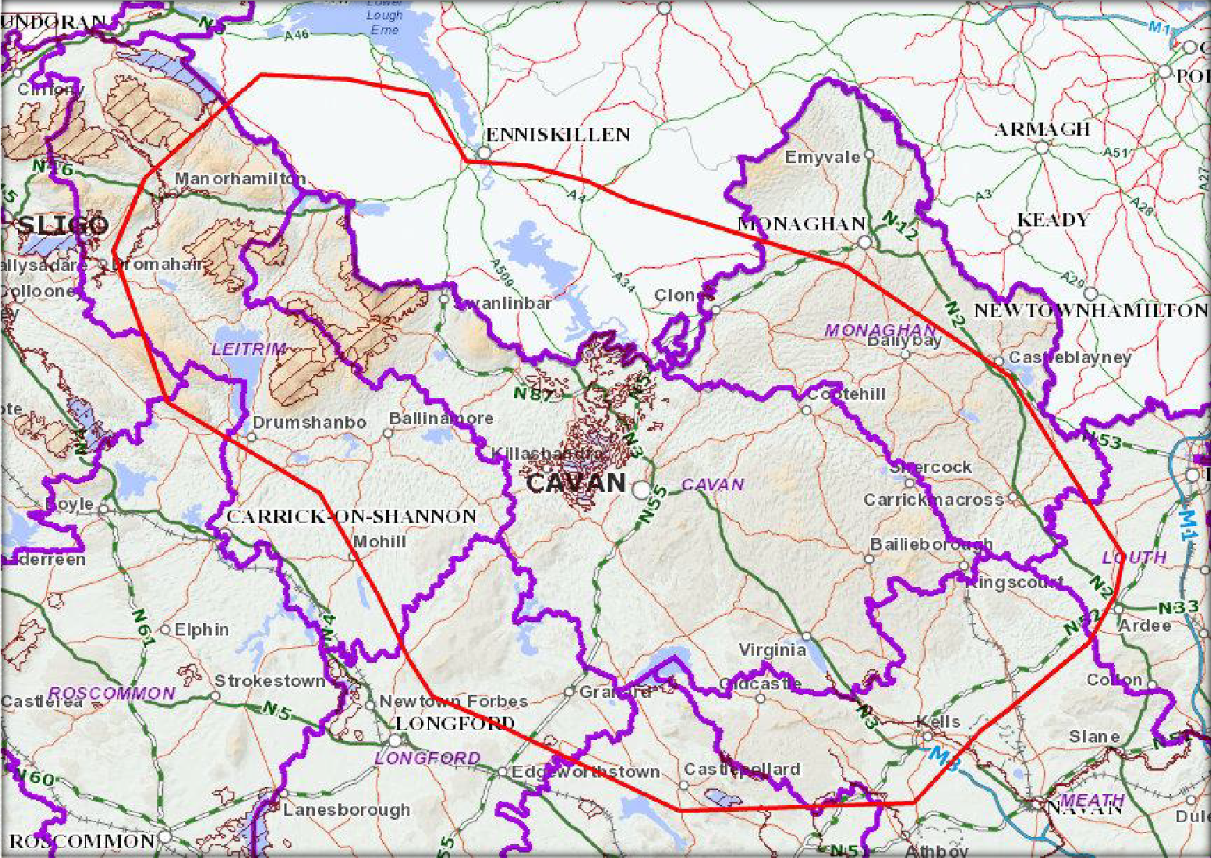
BOLEYBRACK
CORRATIRRIM SAC
LOUGH OUGHTER AND
ASSOCIATED LOUGHS SAC
CUILCAGH – ANIERIN MOUNTAINS SAC
RIVER BOYNE AND RIVER BLACKWATER SAC
KILLYCONNY BOG SAC
Figure 1 - SACS Within County Cavan

AP P R OP R I AT E AS S E S S M E N T ( S T AG E I ) O F TH E CO UN T Y CAV AN L O C AL E C O N OM I C AN D COM M U NI T Y P L AN

SPECIAL PROTECTION AREAS
There are four Special Protection Areas (SPAs) in County Cavan, totalling over 4000 hectares in area. SPAs are designated for the protection of birds and many of the protected bird species listed are dependent on the protected wetlands of County Cavan. Lakes, rivers and their associated wetland habitats such as reed beds, marsh and wet grassland provide vital feeding and nesting sites for these birds. These wetlands and their associated bird species are vulnerable to many threats such as eutrophication, drainage, habitat loss, habitat fragmentation and human recreation. Many wetland bird species in Ireland and Europe have suffered serious declines in recent decades; therefore the protection of the habitats on which they depend is vital for their long-term survival. A summary of the SPAs in County Cavan is presented in Table 3 and a map showing their location is presented in Figure 2.

18

Natura 2000 Site | Brief Description | Qualifying Interests
Lough Oughter Complex  SPA 004049 | The Lough Oughter Complex SPA is of ornithological importance for its wintering waterbird populations. Of particular note is the internationally important population of Whooper Swan that is based in the area. The site also supports nationally important populations of a further two wintering species and, notably, holds the highest breeding concentrations of Great Crested Grebe in the country. Two of the species which occur regularly are listed on Annex I of the E.U. Birds Directive, i.e. Whooper Swan and Greenland White-fronted Goose. | - Great Crested Grebe (Podiceps cristatus) [A005]  - Whooper Swan (Cygnus cygnus) [A038]  - Wigeon (Anas penelope) [A050]  - Wetlands & Waterbirds [A999]
Lough Sheelin  SPA 004065 | Lough Sheelin is a medium to large-sized lake, with a maximum length of 7 km. The lake lies at the top of the Inny River, a main tributary of the River Shannon. It is a typical limestone lake and is fairly shallow (maximum depth 14 m). The trophic status of the lake has varied greatly since the 1970s due to pollution from mainly agricultural sources. Swamp vegetation occurs along parts of the shoreline. There are some very small offshore islands which are mostly wooded. The lake was formerly one of the top trout fisheries in the country. Despite very variable water quality in recent decades, Lough Sheelin remains a very important site for wintering waterfowl and especially diving duck. | - Great Crested Grebe (Podiceps cristatus) [A005]  - Pochard (Aythya ferina) [A059]  - Tufted Duck (Aythya fuligula) [A061]  - Goldeneye (Bucephala clangula) [A067]  - Wetland and Waterbirds [A999]
Lough Kinale and Derragh Lough  SPA 004061 | Lough Kinale is a relatively small lake that is situated immediately downstream of Lough Sheelin and is at the top of the catchment of the Inny River. Derragh Lough, a much smaller system, is connected to Lough Kinale and the Inny River outlet. This is a | - Pochard (Aythya ferina) [A059]  - Tufted Duck (Aythya fuligula) [A061]

 | typical limestone system and is very shallow. The trophic status of the lake has varied greatly since the 1970s due to pollution from mainly agricultural sources. Lough Kinale has two main basins, almost separated by swamp formations. Reed swamp is frequent around the lakes, with a calcium-rich small sedge marsh present along parts of the shore. The lake was formerly an important trout fishery. Areas of bog occur around the margins of the lakes in places but some of these have been planted with conifers. Despite very variable water quality in recent decades, Lough Kinale and Derragh Lough remain an important site for wintering waterfowl, especially diving duck.
The River Boyne and River Blackwater  SPA 004232 | The River Boyne and River Blackwater SPA supports nationally important numbers of Alcedo atthis. Other species which occur within the site include Cygnus olor, Anas crecca, Anas platyrhynchos, Phalacrocorax carbo, Ardea cinerea, Gallinula chloropus, Gallinago gallinago and Riparia riparia. | - Common Kingfisher Alcedo atthis

Table 3 – A Summary of the SPAs within County Cavan

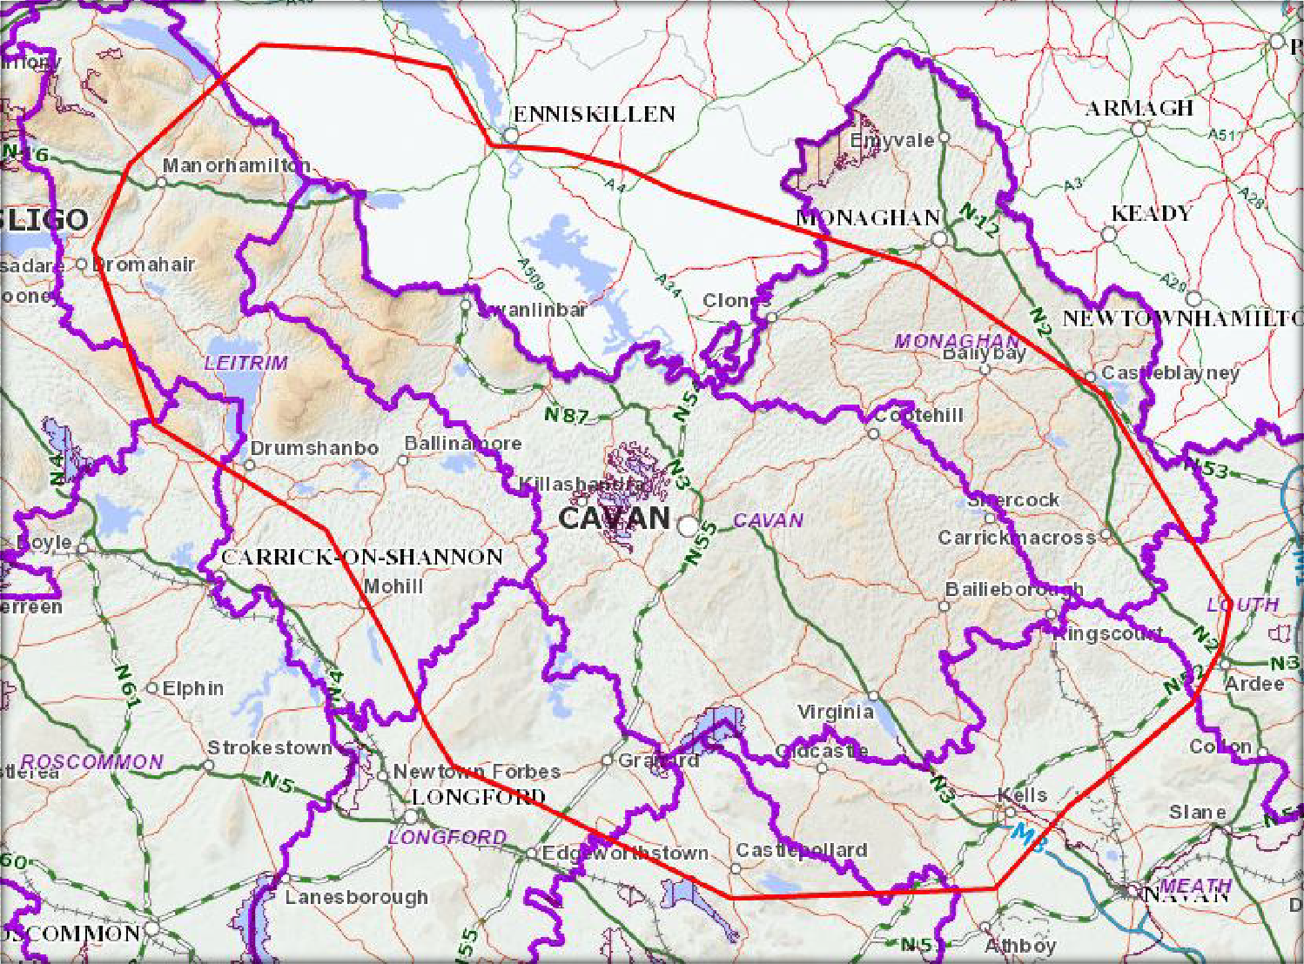
LOUGH OUGHTER COMPLEX SPA
LOUGH KINALE AND
DERRAGH LOUGH SPA
LOUGH SHEELIN SPA
RIVER BOYNE AND RIVER BLACKWATER SPA
Figure 2 – SPAs within County Cavan

AP P R OP R I AT E AS S E S S M E N T ( S T AG E I ) O F TH E CO UN T Y CAV AN L O C AL E C O N OM I C AN D COM M U NI T Y P L AN

  - 3 NA T U R A 2000 S I T E S W I T H IN 15 K M O F CO U N T Y CA V A N
SPECIAL CONSERVATION AREAS AND SPECIAL PROTECTION AREAS
In accordance with the guidelines produced by the DoEHLG, all Natura 2000 sites within 15km of the border of County Cavan have been included in the screening process, including any designated sites in Northern Ireland. This ensures that the screening process will cover all designated sites likely to be impacted upon from the proposed area. There are eight SACS within 15km of County Cavan and two SPAs. These sites are summarised in Table 4 (Republic of Ireland Sites) and Table 5 (Sites in Northern Ireland). Sites in the Republic of Ireland are shown in Figure 3.

22

Natura 2000 Site | Brief Description | Qualifying Interests
Ardgullion Bog  SAC 002341 | Ardaguillion Bog is located 5 km north - east of Edgeworthstown, mainly in the townlands of Cloonshannagh (Coolamber Manor Demesne) and Ardaguillon in Co. Longford. The site comprises a raised bog that includes both areas of high bog and cutover bog. | - Active raised bog [7110]  - Degraded raised bog still capable of natural regeneration [7120]  - Depressions on peat substrates of the Rhynchosporion  [7150]
Aroo Mountatin  SAC 1403 | Arroo Mountain is a large mountain complex which is comprised of blanket bog, heathland, upland grassland, calcareous flushes, wooded ravines, limestone gorges and steep limestone cliffs which have developed on top of an undulating limestone plateau. It is the most north - easterly part of the Ben Bulben range of mountains, and is located 3 km south - west of Kinlough in Co. Leitrim. | - Blanket bogs (* if active bog) [7130]  - Northern Atlantic wet heaths with Erica tetralix [4010]  - Calcareous rocky slopes with chasmophytic vegetation [8210]  - Petritying springs with tufa formation (Cratoneurion) [7220]  - Calcareous and calschist screes of the mountain to alpine level [8120]
Garriskill Bog  SAC 000679 | This raised bog site lies 3 km west of Lough Derravaragh and 3 km east of Rathowen in Co. Westmeath. It is bounded to the south - east and south - west by the rivers Inny and Riffey. It is considered an excellent example of a midland raised bog. A large proportion of the uncut high bog (c. 40%) comprises very wet active raised bog, an unusually high figure for raised bogs in the eastern half of the country. | - Active raised bog [7110]  - Degraded raised bog still capable of natural regeneration [7120]  - Depressions on peat substrates of the Rhynchosporion  [7150]
Garriskill Bog  SPA 004102 | This site is in the range of the midland lakes flock of wintering Anser albifrons flavirostris which is centred on four major lakes (Derravaragh, Iron, Owel and Ennell). There are 16 known feeding | - Greenland white-fronted goose Anser albifrons flavirostris  [A395]

 | sites, mostly on intensively managed grassland. In the past the site has been utilised by the geese, but nowadays use of raised bogs is rare. Falco columbarius has been noted at Garriskil during the breeding season. Gallinago gallinago, Numenius arquata and Tringa totanus also breed. Tyto alba has been recorded hunting along the margins of the bog and Lagopus lagopus is occasional.
Kilroosky Lough Cluster  SAC 001786 | Kilroosky Lough Cluster straddles the border with Northern Ireland, and is located approximately 2 km north - west of Clones, Co. Monaghan. The site consists of three separate areas which contain several calcium - rich, clean water (oligo-mesotrophic) lakes and their marginal fen vegetation. | - Hard oligo-mesotrophic waters with benthic vegetation of Chara spp. [3140]  - Alkaline fens [7230]  - Calcareous fens with Cladium mariscus and species of the Caricion davallianae [7210]  - White-clawed Crayfish (Austropotamobius pallipes) [1092]
Lough Bane and Lough Glass  SAC 002120 | This site is located on the Meath/Westmeath border, about 10 km south of Oldcastle. It comprises three lakes situated in a shallow valley. Lough Bane is by far the largest of the group, with the much smaller Lough Glass occurring immediately to the east and Lough Glass North to the north - west. The lakes occur at the headwaters of the River Deel, with the main outflow at the south - east end of Lough Bane. The outflow is not very substantial and partly overgrown with vegetation. The connection between Lough Glass and Lough Bane has now been severed and the flow from Lough Glass is diverted to the south - west. The water level has dropped over the years and has exposed soft marl along parts of the shore. | - Hard oligo-mesotrophic waters with benthic vegetation of Chara spp. [3140]  - White-clawed Crayfish (Austropotamobius pallipes) [1092]
Lough Derravaragh  SPA 004043 | Lough Derravaragh is located approximately 12 km north of Mullingar town. It is a medium- to large-sized lake of relatively shallow water (maximum depth 23 m). The lake extends along a | - Whooper Swan (Cygnus cygnus) [A038]  - Pochard (Aythya ferina) [A059]

 | south-east/north-west axis for approximately 8 km. The Inny River, a tributary of the River Shannon, is the main inflowing and outflowing river. It is a typical limestone lake with water of high hardness and alkaline pH, and is classified as a mesotrophic system. | - Tufted Duck (Aythya fuligula) [A061]  - Coot (Fulica atra) [A061]  - Wetland and Waterbirds [A999]
Lough Gill  SAC 001976 | This site includes Lough Gill, Doon Lough to the north - east, the Bonet River (as far as, but not including, Glenade Lough), and a stretch of the Owenmore River near Manorhamilton in Co. Leitrim. Lough Gill itself, 2 km east of Sligo town, lies at a geological junction of ancient metamorphic rocks which produce acid groundwater, and limestone which dissolves in the groundwater. The site is of importance for three habitats listed on Annex I of the  E.U. Habitats Directive, including one with priority status. It is also noted for the high number of rare or scarce animal and plant species. | - Natural eutrophic lakes with Magnopotamion or  Hydrocharition-type vegetation [3150]  - Alluvial forests with alder Alnus glutinosa and ash Fraxinus excelsior  - Old sessile oak woods with Ilex and Blechnum [91A0]  - Sea lamprey (Petromyzon marinus) [1095]  - White-clawed Crayfish (Austropotamobius pallipes) [1092]  - Brook Lamprey (Lampetra planeri) [1096]  - River Lamprey (Lampetra fluviatilis) [1099]  - Salmon (Salmo salar) [1106]  - Otter Lutra lutra [1355]
Lough Lene  SAC 002121 | This lake is situated 4 km north - east of Castlepollard in Co. Westmeath. It is a deep (20 m maximum depth), clear, hard - water lake with marl deposition (especially noticeable on the margins). Unpolluted hard - water lakes such as Lough Lene are becoming increasingly rare in Ireland and in Europe, and are of a type that is listed on Annex I of the E.U. Habitats Directive. This site is thus of conservation importance. | - Hard oligo-mesotrophic waters with benthic vegetation of Chara spp.  - White-clawed Crayfish (Austropotamobius pallipes) [1092]
Lough Melvin  SAC 000428 | Lough Melvin is situated in the extreme north - west of Co. Leitrim, about 4 km south of Bundoran. The area is underlain by sedimentary calp - limestone, shale and sandstone. Lough Melvin is | - Oligotrophic to mesotrophic standing waters with vegetation of the Littorelletea uniflorae and/or of the Isoeto-Nanojuncetea [3130]

 | an oligo - mesotroph ic lake and is approximately 13 km long by 3 km wide. The mean depth of the lake is 8.5 m, the maximum depth being 45 m. A number of inflowing and outflowing streams and rivers are included in the site, for instance, the Drowes River links the lake to Done gal Bay. Several large islands occur on the lake. | - Salmon (Salmo salar)  - Otter (Lutra lutra)
Moneybeg and Clareisland Bog  SAC 002340 | This site is located on the border of Counties Meath and Westmeath, 9 km east of the town of Granard. It is situated mainly in the townlands of Clareisland or Derrymacegan, Williamstown an d Moneybeg in Co. Westmeath, and Ross in Co. Meath. The Moneybeg and Clareisland Bogs site is of consider able conservation significance as it comprises two raised bogs with semi  - natural lake margins. These are found at the north - eastern extreme of the range of raised bogs in Ireland. | - Active raised bog [7110]  - Degraded raised bog still capable of natural regeneration [7120]  - Depressions on peat substrates of the Rhynchosporion  [7150]
White Lough, Ben Lough and Lough Doo  SAC 001810 | White Lough, Ben Loughs and Lough Doo SAC is comprised of four hard water lakes in a small, poorly - drained valley, 4 km east of Castlepollard, Co. Westmeath. This site is of considerable conservation significance for its hard water lakes and for the occurrence of White - clawed Crayfish. The variety of habitats within this valley and the contrasting vegetation types add further to its interest. | - Hard oligo-mesotrophic waters with benthic vegetation of Chara spp.  - White-clawed Crayfish (Austropotamobius pallipes) [1092]

Table 4 – SACs and SPAs (Republic of Ireland) within 15km of County Cavan

Site Name and Code | Qualifying Interests
Fardrum and Roosky Turloughs SAC UK0030068 | - Turloughs [3180]
Cuilcagh Mountains SAC UK0016603 | - Blanket bogs (* if active bog) [7130]  - Natural dystrophic lakes and ponds [3160]  - Northern Atlantic wet heaths with Erica tetralix [4010]  - European dry heaths [4030]  - Alpine and boreal heaths [4060]  - Siliceous scree of the montane to snow levels [8110]  - Siliceous rocky slopes with chasmophytic vegetation [8220]
West Fermanagh Scarplands SAC UK0030300 | - Semi-natural dry grasslands and scrubland facies on calcareous substrates(*important orchid sites) [6210]  - Molinia meadows on calcareous, peaty or clayey-silt- laden soils [6410]  - Limestone pavements [8240]  - Tilio-Acerion forests of slopes, screes and ravines [9180]  - Natural eutrophic lakes with Magnopotamion or  Hydrocharition-type vegetation  - Northern Atlantic wet heaths with Erica tetralix [4010]  - Blanket Bogs (if active bog)[7130]  - Petrifying springs with tufa formation (Cratoneurion) [7220]  - Alkaline fens [7230]
Upper Lough Erne SAC UK0016614 | - Natural eutrophic lakes with Magnopotamion or  Hydrocharition-type vegetation

- Old sessile oak woods with Ilex and Blechnum [91A0]
- Alluvial forests with alder Alnus glutinosa and ash
Fraxinus excelsior [91E0]
- Otter (Lutra lutra) [1355]
Magheraveely Marl Loughs SAC UK0016621 | - Hard oligo-mesotrophic waters with benthic vegetation of Chara spp.  - Alkaline fens [7230]  - Calcareous fens with Cladium mariscus and species of the Caricion davallianae [7210]  - White-clawed Crayfish (Austropotamobius pallipes) [1092]
Upper Lough Erne SPA UK9020071 | - Whooper Swan (Cygnus cygnus) [A038]
Slieve Beagh-Mullaghfad-Lisnakea SPA UK9020302 | - Hen harrier (Circus cyaneus) [A082]

Table 5 – SACs and SPAs (Northern Ireland) within 15km of County Cavan

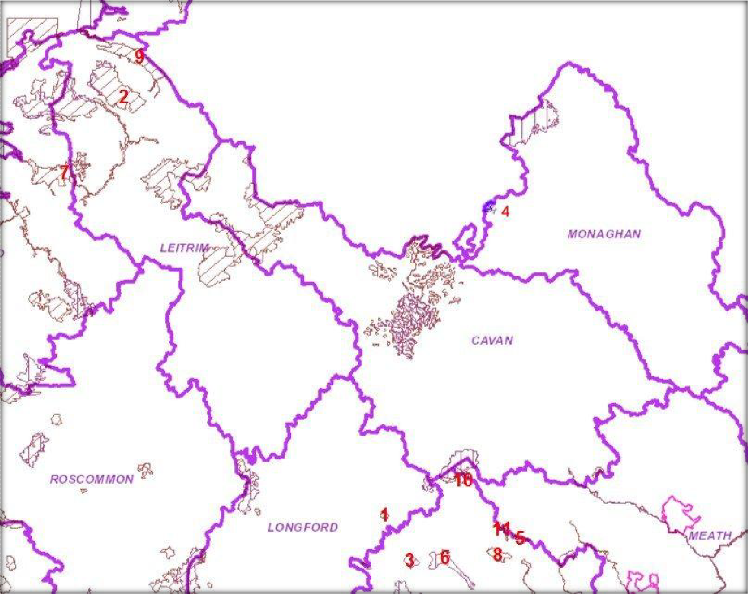Legend

1 – Ardgullion Bog SAC 2 – Aroo Mountain SAC
- – Garriskill Bog SAC/SPA
- – Kilroosky Lough Cluster SAC
- – Lough Bane & Lough Glass SAC 6 – Lough Derravaragh SPA
- – Lough Gill SAC
- – Lough Lene SAC
- – Lough Melvin SAC
- – Moneybeg & Clare Island Bog SAC
- – White Lough, Ben Lough and Doo Lough SAC

Figure 3 – Natura 2000 Sites within 15km of County Cavan

  - 4 CO N S E R V A T I ON OB J E C T I V E S
The NPWS has not yet prepared any Site Specific Conservation Objectives for any of the sites listed in Tables 2, 3 or 4.

The generic conservation objectives of all these sites are:

- To maintain the favourable conservation status of the qualifying interests (outlined above) of the SAC or SPA.

- To maintain the extent, species richness and biodiversity of the entire site.

- To establish effective liaison and co-operation with landowners, legal users and relevant authorities.
The favourable conservation status of a habitat is achieved when:

    - Its natural range and area it covers within that range is stable or increasing and the specific structure and functions which are necessary for its long‐term maintenance exist and are likely to continue to exist for the foreseeable future;

    - The conservation status of its typical species is favourable.

The favourable conservation status of a species is achieved when:

    - The population dynamics data on the species concerned indicate that it is maintaining itself on a long ‐term basis as a viable component of its natural habitats;

    - The natural range of the species is neither being reduced nor is likely to be reduced for the foreseeable future;

    - There is, and will probably continue to be, a sufficiently large habitat to maintain its populations on a long‐term basis.

Since the conservation objectives for the Natura 2000 sites focus on maintaining and / or restoring the favourable conservation condition of the qualifying interests and features of all the sites listed above, then this screening process concentrated on assessing the potential implications of the Cavan Local Economic and Community Plan and its High Level Goals on the qualifying interests of each site.

SCR E E N IN G OF POT E N T IA L EF F E CT S
The High Level Goals (HLG) of the Cavan LECP were outlined in Table 1. Each of the twelve HLG have been assessed in relation to any potential impacts that their implementation may have on the Natura 2000 sites identified within the study area (County Cavan and 15km beyond). They have been considered on their own and in combination with other plans and projects.

Many of the HLG are strategic and they relate to the promotion of Co. Cavan whilst working with and supporting community groups. The community element of the HLG (two goals) will strive to develop and enhance community space, offer support for community groups, assist the work of volunteers within the county as well as supporting organisations that work with youth groups, traveller groups and the elderly. Supporting environmental initiatives such as Tidy Towns and the Green Schools Campaign is also identified as an objective under the community elements of the HLG. The actions outlined do not relate to future land-use development or specific projects that could have impacts upon Natura 2000 sites. Therefore, as the community HLG defined within the LECP are strategic in nature and do not relate to the physical environment or land use, they are not expected to result in any impacts upon Natura 2000 sites.

The economic element of the HLG (ten goals) relates to the promotion of business and tourism opportunities within Co. Cavan. Most of these are also strategic and include actions to attract new businesses, the promotion of start-up companies, entrepreneurs and research and development. Some actions outline the development of specific facilities, e.g., the development of high quality enterprise parks, the improvement of waste water treatment facilities, the development of renewable energy projects and the improvement of equestrian facilities. In addition, actions that support the development of tourism initiatives at Cavan Burren Park, Castlesaunderson Demesne and Killykeen Forest Park have been identified, along with the development of Greenways, angling facilities and walkways. These actions relate to the environment and to projects that might impact upon certain designated sites. However, at this stage they are of a broad strategic nature. The development of any specific projects arising from these actions will be subjected to normal planning processes and requirements, including compliance with Articles 6(3) of the Habitats Directive where applicable. Any projects arising from the actions in the LECP that have the potential to impact upon a Natura 2000 site will go through the Appropriate Assessment process.

Article 6(3) of the Habitats Directive also requires that the Appropriate Assessment process considers other plans and programmes that may, in combination with the specific plan being considered give rise to impacts upon Natura 2000 sites. The HLG outlined in Table 1 are harmonious with the actions and objectives outlined in the Cavan County Development Plan 2014 - 2020. This plan has been screened for Appropriate Assessment (Ecologists Ireland, 2014) and it has also undergone a Strategic Environmental Assessment (SEA). The screening report for the County Development Plan concluded that “there are likely to be no significant effects on the Natura 2000 sites and that appropriate protection and mitigation, where necessary, in respect of the Natura 2000 Network has been formulated within the Amended Draft Cavan County Development Plan to ensure that changes in land utility, development and the potential impacts from permission based on policies and objectives detailed in the Plan conform to the requirements of the European Communities (Birds and Natural Habitats) Regulations 2011”.

In conclusion, the implantation of the Cavan Local Economic and Community Plan will have no significant impacts upon any Natura 2000 site either on its own or in combination with other plans and projects. This plan does not need to proceed to Stage II of the Appropriate Assessment process, namely the Natura Impact Statement.

  - 1 F I N D I N G O F NO S I G N I F I C A N T E F F E C T S

Finding of No Significant Effects Report Matrix
Name of project | Cavan Local Economic and Community Plan (Draft)
Name and location of Natura 2000 site | All of the Natura 2000 sites within Cavan and 15km from its boundary have been considered.
Description of project | This plan will provide a strategic framework guiding local economic and community development in County Cavan for the next six years. It is the central strategy that will set the agenda for statutory agencies, elected representatives, community and voluntary groups and business interests to work collaboratively over the life of the plan for the betterment of County Cavan. It will ensure that organisations in Cavan work in partnership to achieve that vision for County Cavan.
Is the project directly connected with or necessary to the management of the sites? | The Cavan LECP is not directly connected with or necessary to the management of any Natura 2000 site. Its main purpose is to promote the well being and quality of life of communities in Cavan, whilst promoting business and tourism in a sustainable manner.
Are there other projects or plans that together with project being assessed could affect the sites? | The implantation of the Cavan LECP will have no significant impacts upon any Natura 2000 sites either on its own or in combination with other plans and projects.
The Assessment of Significance of Effects
Describe how the project is likely to affect the Natura 2000 site | Having regard to the strategic nature of this plan, it is considered that there is no potential for significant effects either from the proposed plan on its own or in combination with other plans and projects.
Explain why these effects are not considered significant | Any projects arising from the actions outlined within the HLG of this plan will be screened for Appropriate Assessment as required.
List of agencies consulted: | Development Applications Unit / National Parks and Wildlife Service
Data Collected to Carry out the Assessment
Who carried out the assessment | Noreen McLoughlin, MSC, MCIEEM. Consultant Ecologist
Sources of data | NPWS, EPA, National Biodiversity Data Centre, Cavan County Council
Level of assessment completed | Stage1 Appropriate Assessment Screening

Appendix I : R E F E R E N CE S

Cavan County Development Plan 2014 – 2020. Planning Department, Cavan County Council.
Ecologists Ireland (2014) Stage 1 Screening for Appropriate Assessment of the Amended Draft Cavan County Development Plan (2014 – 2020).
NPWS (2013) The Status of Protected EU Habitats and Species in Ireland. Overview Volume
1. Unpublished Report, National Parks and Wildlife Service, Department of Arts, Heritage and the Gaeltacht, Dublin, Ireland.

NPWS - Various reports pertaining to relevant Natura 2000 sites.

AP P R OP R I AT E AS S E S S M E N T ( S T AG E I ) O F TH E CO UN T Y CAV AN L O C AL E C O N OM I C AN D COM M U NI T Y P L AN

35

