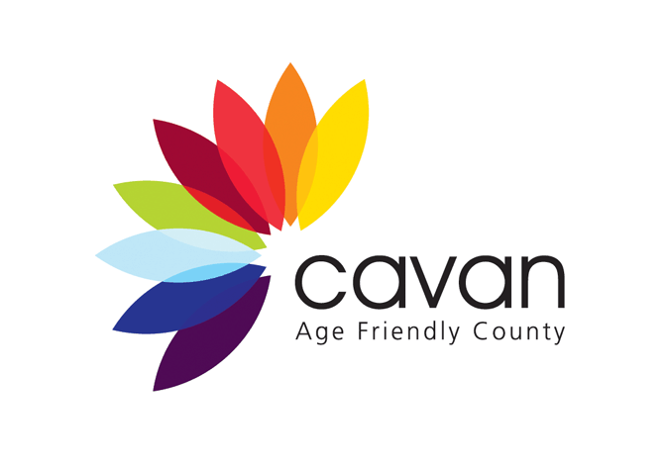
Cavan Older People’s Council
Registration Form
If you (or your group) wish to become a member of the Cavan Older People’s Council, please complete this form.
More information about the Council is provided on the reverse of this page.
Your name: __________________________________
Name of group you represent
(if relevant): __________________________________
Postal Address including Eircode: __________________________________
__________________________________
Telephone number __________________________________
Email address __________________________________

Signed __________________________________

Return your completed form to: Social Inclusion Unit, Cavan County Council, Community & Enterprise, Farnham Centre, Farnham Street, Cavan. Telephone (049) 437 8654 or email agefriendly@cavancoco.ie for further information.
Please note for GDPR purposes: Your contact details will be kept on file by Cavan County Council for the purposes of contacting you to send you information or notify you about events which may be of interest. We will not transfer your personal information to third parties.

Cavan Older People’s Council

Cavan Older People’s Council (previously ‘Forum’) was set up in 2013 as a way of bringing together all the older people’s groups in County Cavan and representing the views of older people. It works closely with local agencies and the voluntary sector to deliver the county’s Age Friendly Strategy. This is a plan that aims to bring about improvements in the quality of life of older people in the county over a three year period.
The Council itself is a network of about 80 older people’s and social services groups and individuals. The full network meets once a year at its AGM (Annual General Meeting) and on other occasions for consultations and events.
The Council has an Executive Committee which is elected from its members. The Executive Committee meets monthly. It helps to deliver actions in the Age Friendly Strategy, for example, running a weekly drop in morning for older people with various talks and activities provided.
The Council has also been very involved in developing an Age Friendly Business Scheme in Cavan town, setting up an Age Friendly website for Cavan and carrying out research on the needs of older people.
If you are interested in joining the Cavan Older People’s Council, you simply need to fill in this registration form. Once you become a member, you will be included on the mailing list for any newsletters, information about events etc. Members can also put themselves forward for election to the Executive Committee at the AGM.

